# **Data Science Virtual Machine and Deep Learning VM – Currency Detector Hands-On Workshop**

Contents

**Data Science Virtual Machine and Deep Learning VM – Currency Detector Hands-On Workshop** 1

Deploying a Windows Data Science Virtual Machine – Using the Azure portal 2

Connecting to a Data Science Virtual Machine – Using Remote Desktop & Exploring the VM and some of the installed tools 10

Deploying a Deep Learning Virtual Machine – Using the Azure portal 15

Deploying a Linux Data Science Virtual Machine – Using the Azure portal 20

Connecting to Deep Learning VM or Linux DSVM – Using SSH 26

Configure Remote Machines in Visual Studio 29

Login to Jupyter Hub on the Deep Learning VM 30

Clone the GitHub Repository for SeeingAI-Currency-Detection 33

Upload Notebooks from git clone into the **currency_detector** folder 34

View and Open the notebook in Juypter Hub 35

Download images from Azure Blob and upload to Linux DLVM or DSVM 36

Run the code in Jupyter Hub Notebook 42

Run the code in Visual Studio AI Tools 44

Run the code in Visual Studio Code Tools for AI 48

Other Tools 50

# Deploying a Windows Data Science Virtual Machine – Using the Azure portal

1. Go to <http://portal.azure.com>  
   Sign in with your Azure subscription credentials and you will see the portal dashboard.  
   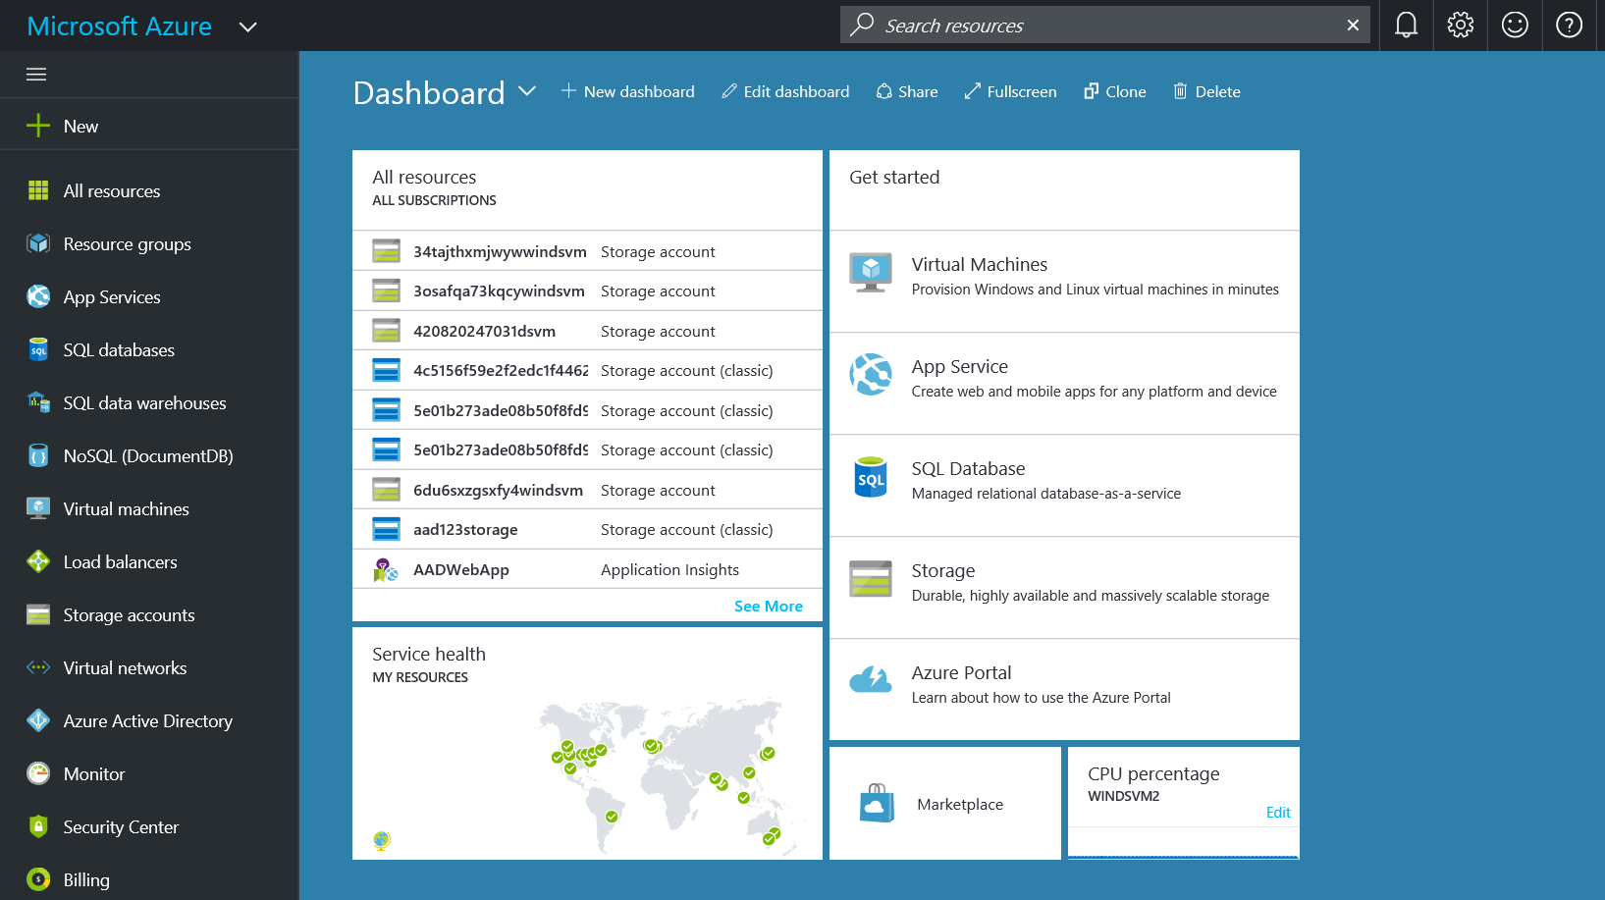
2. Click on Create a resource  
   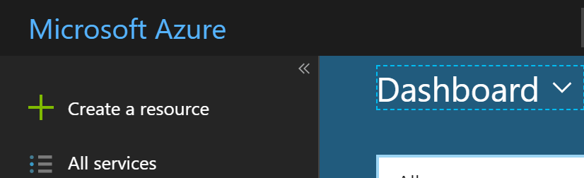
3. Type in **data science** in the search bar and then press Enter. You may also click on the suggestions, but if you just search for data science, you will see all options in the results.  
   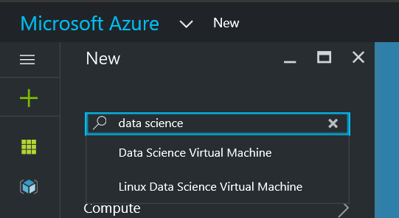
4. The search results should look like the figure below. Choose the **Data Science Virtual Machine 2016**   
   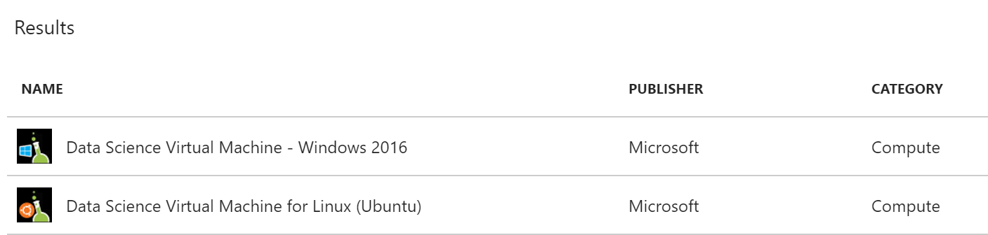
5. Once you chose the VM version, you will see the next frame that has some specific information. You can click ‘Create’ to start the creation process. The deployment model for DSVM is pre-set to be Azure Resource Manager (ARM). You may need to click on Want to deply programmatically? Get started 🡪 to enable ARM deployments

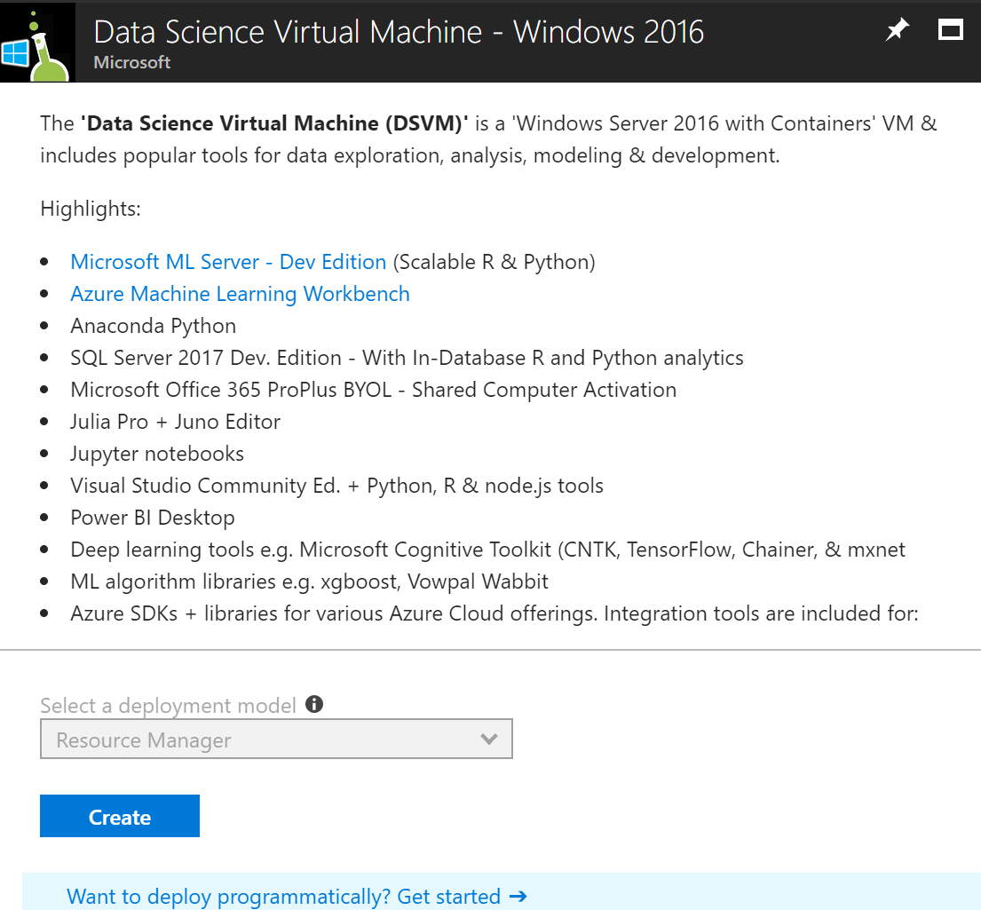

1. Once you press ‘Create’ you will arrive at the ‘Create Virtual Machine’ frame. Here, you will be going through 4 stages of creation: Basics >> Size >> Settings >> Summary.  
   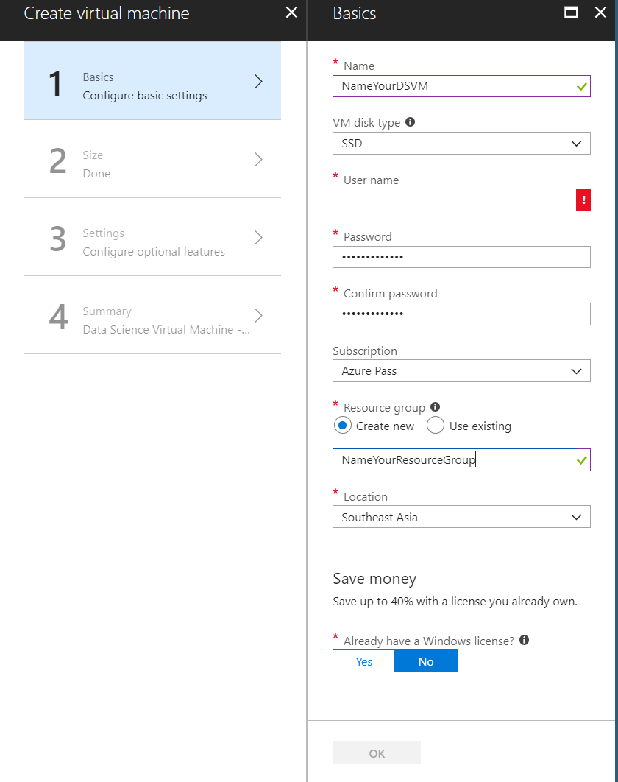
2. Fill out the fields in the ‘Basics’ tab, and chose the subscription if you have more than one and choose the data center region/location where you want your VM to be deployed to. Typically, geographically closest is the most common choice. Press ‘OK’ when you are done.  
   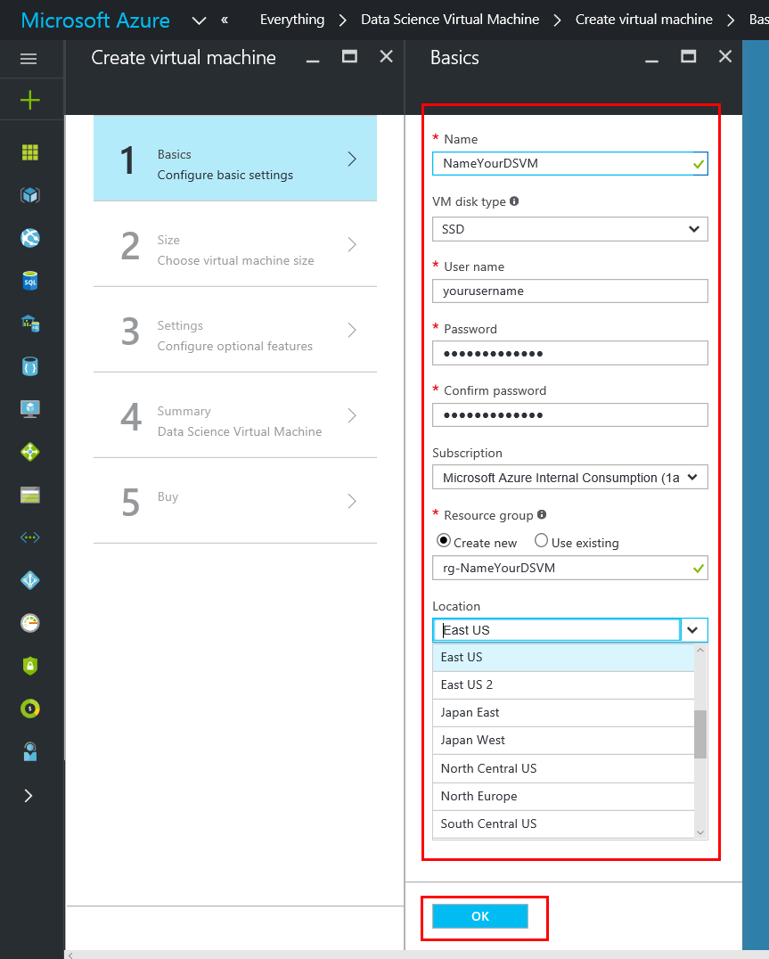
3. You may see a warning/error when entering your password as it would need to adhere to some complexity requirements, for security reasons, refer to the tooltip for exact requirements.   
   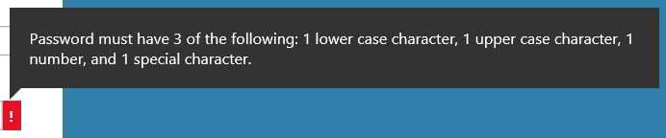
4. Additionally, you may either chose to create a new resource group to encapsulate all the related resources for your VM. This is a logical reference to collectively refer to related resources. You may also choose an existing resource group. Be sure to name resource groups in a manner where they are self-explanatory of the resources they encapsulate or their purpose. Click ‘OK’ when done.  
   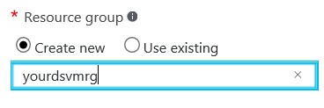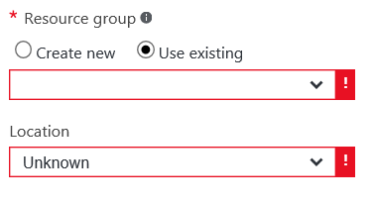
5. On the ‘Size’ tab, select the desired configuration of the machine that you want. Since the purpose of this instance is ‘Data Science’, we recommend choosing an instance size with 4 or more cores and 14GB or more of RAM. You can scale the instances up or down as per your requirement. Additionally, you can also shut down and deallocate the instances when not in use. This may be done programmatically as well. Click ‘Select’ to proceed to the ‘Settings’ tab. 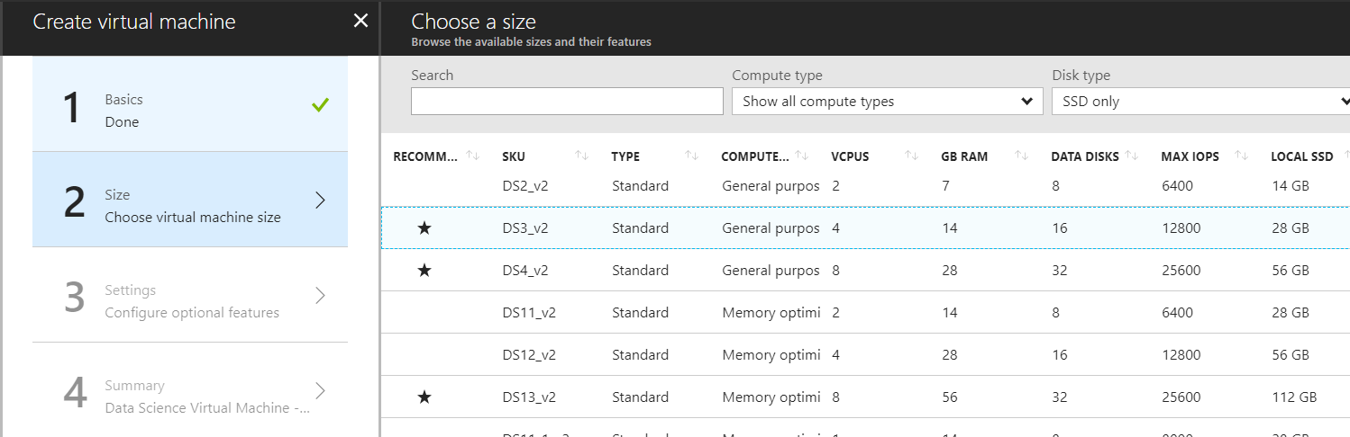
6. On the ‘Settings’ tab you can select or specify different locations or names etc. for some resources like storage and network. The form is pre-populated with some generated values that are automatically built from the initial names etc. that you specified in the ‘Basics’ tab. You can choose to change these or use these generated values. Additionally, there are a few settings to note. Here is where you can click on ‘Extensions’ and add a post provisioning extension like an Anti-Malware solution etc. or bring in your custom scripts and extensions. You can also enable ‘Guest OS diagnostics’ which is off by default. This gives you metrics every minute for the VM and can use them to create alerts and stay informed on your applications etc. Chose RDP (3389) for Select public inbound ports. Click OK

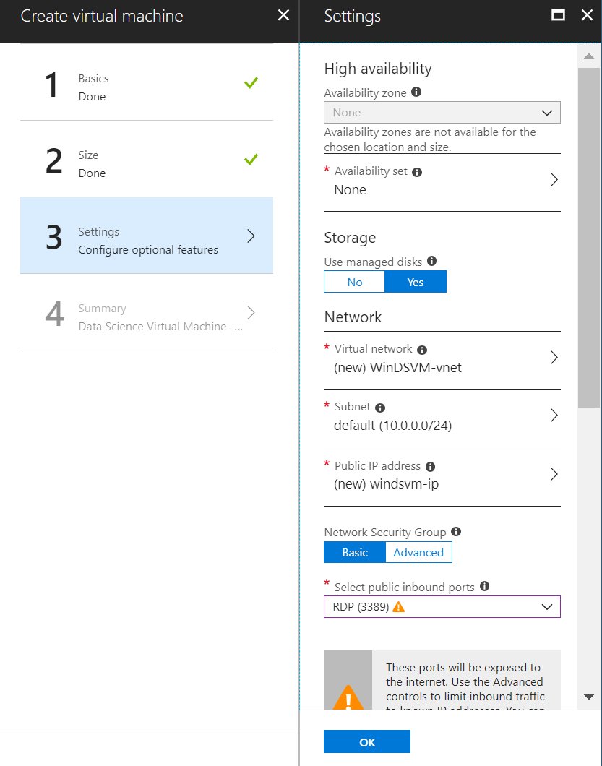

1. The Summary tab is mostly for review. Do verify the details that you have specified in the previous steps. This step also allows you to click on the link to “Download template and parameters”. This option allows you to procure the Azure Resource Manager (ARM) templates for your VM specification so you can deploy the same configuration programmatically without the use of the portal. Click Create.  
   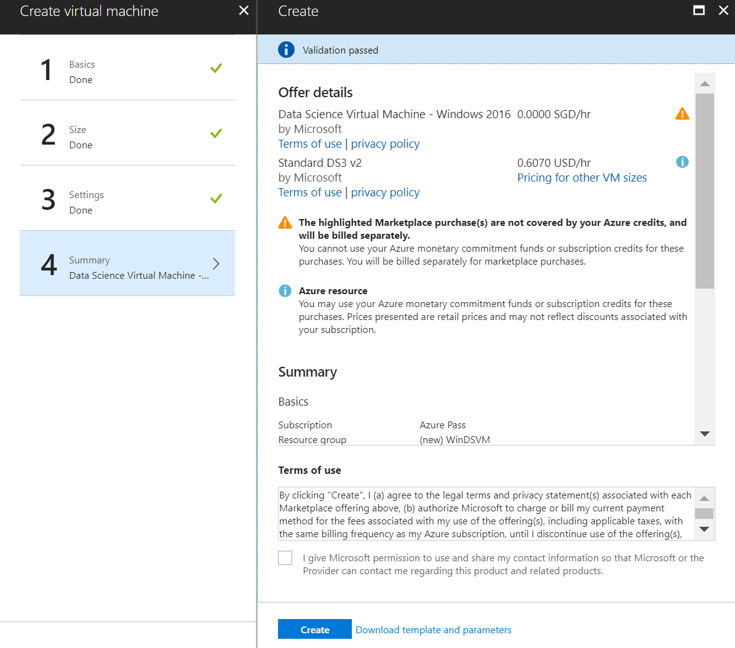
2. (OPTIONAL) If you do click on “Download Template and parameters”, the download interface will look like the figure below.  
   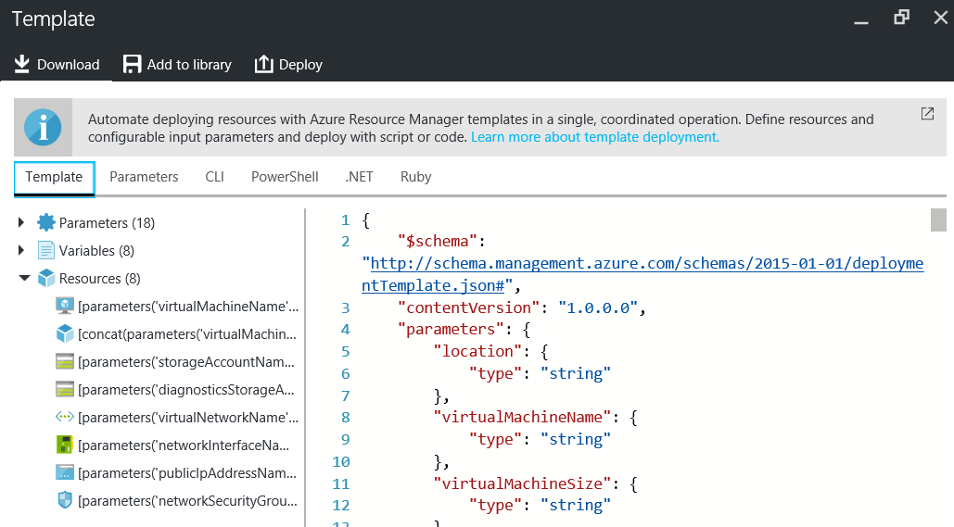
3. Once you click ‘Create’, you will be taken back to the portal dashboard and a new tile will show up like the figure below. This will read, “Deploying Data Science Virtual Machine”. Your DSVM is now being provisioned along with its related resources. This process will take approximately 5 minutes.  
   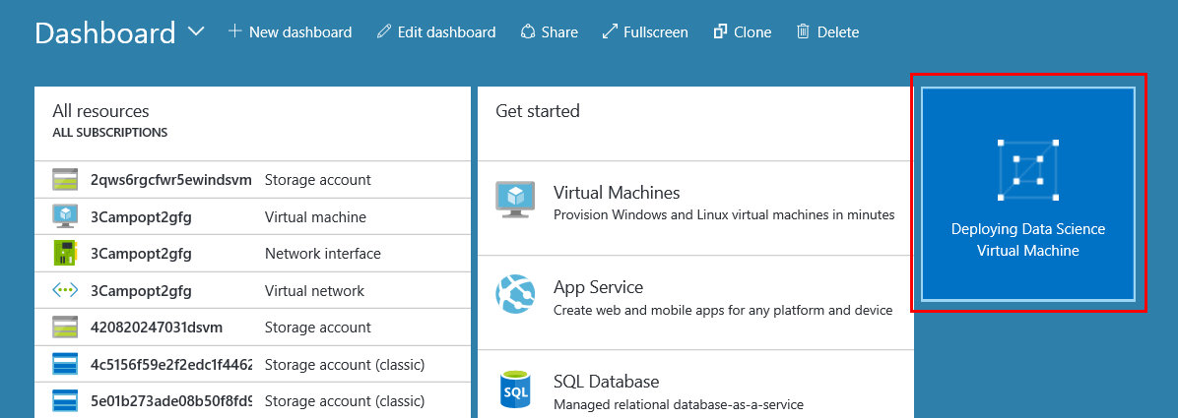
4. Once complete (after about 7 minutes) you will see a notification on the top right that reads “Deployment Successful” and your tile will change to the previously specified name for your DSVM.  
   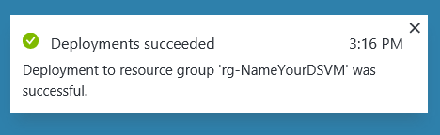 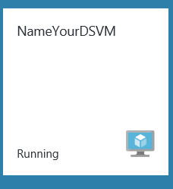

# Connecting to a Data Science Virtual Machine – Using Remote Desktop & Exploring the VM and some of the installed tools

1. You can now Click on the Tile for your DSVM. This will open the frame for your VM and give you numerous options, links and charts with dashboards showing the per minute diagnostics etc. if you had turned them on. You can now Click on the “Connect” button to download the RDP (remote desktop) file which is pre-configured with your VM’s details. You can also use this frame to restart, stop or delete the VM.   
   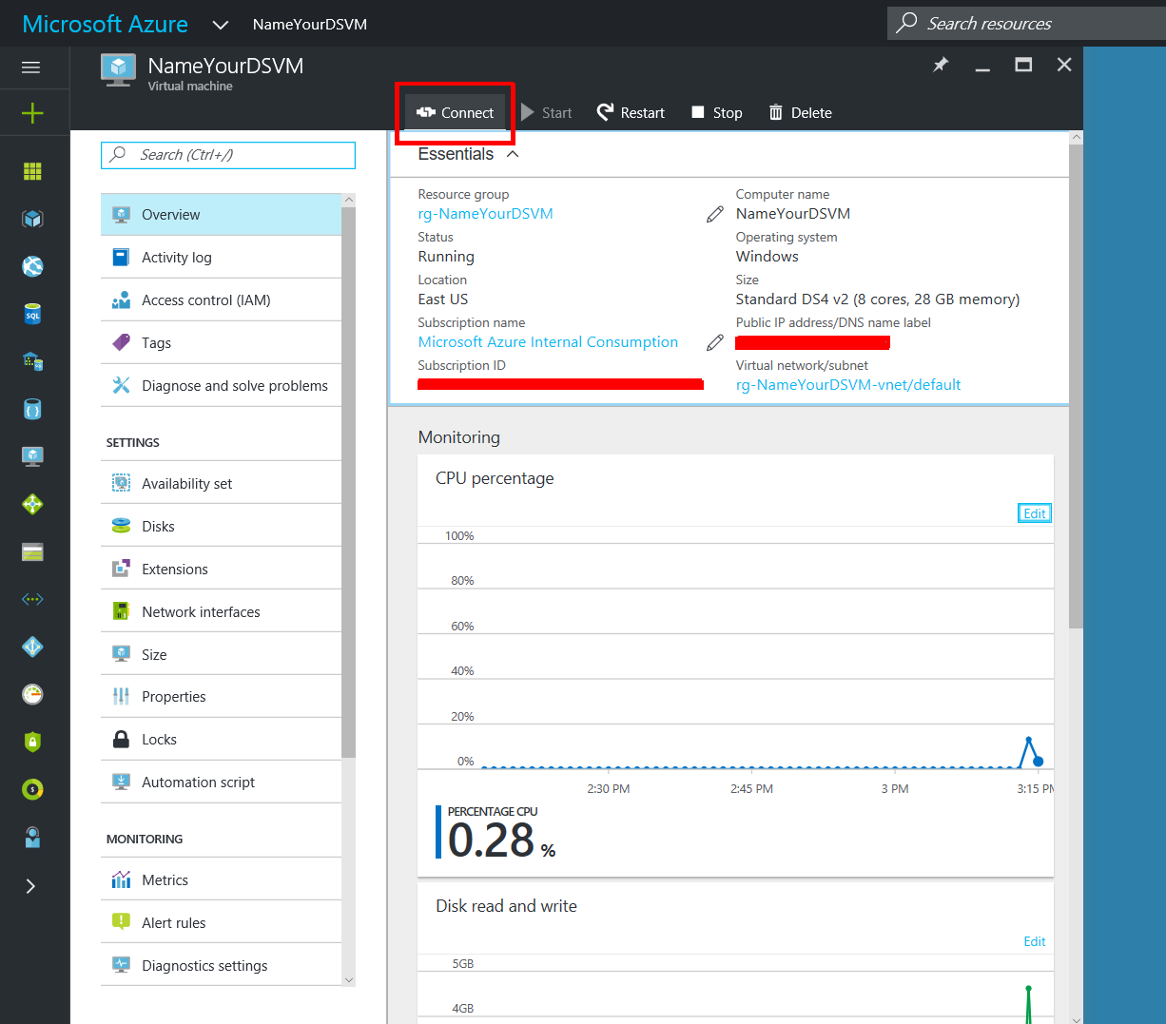
2. Download RDP File. It show up as a download in your browser

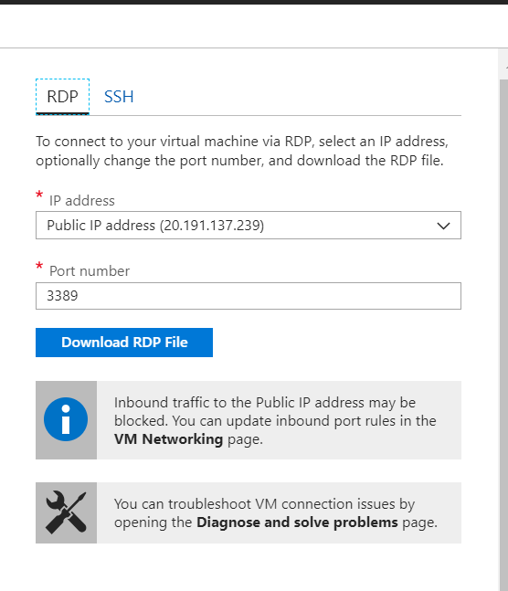

1. The first time you connect using this RDP connection to your created VM, you will see a publisher warning. Please ignore this and tick the ‘Don’t ask me again for connections to this computer’ tock box to stop seeing this.   
   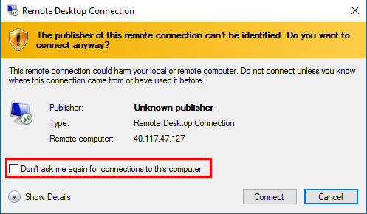
2. Click on Use a different account, enter your credentials and click OK  
   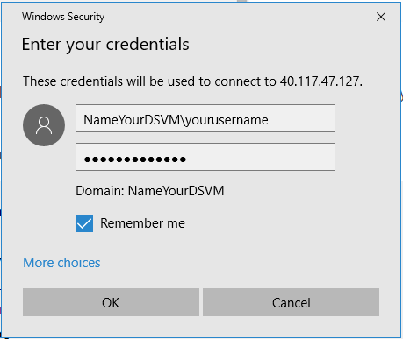
3. You will get another warning is because the VM is not in a domain yet where there is a trusted certificate provider. Please ignore this and tick the ‘Don’t ask me again for connections to this computer’ tock box to stop seeing this. Click Yes  
   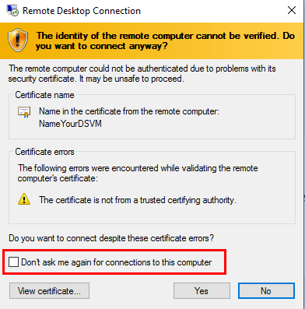
4. You will now be logged in to your DSVM:  
   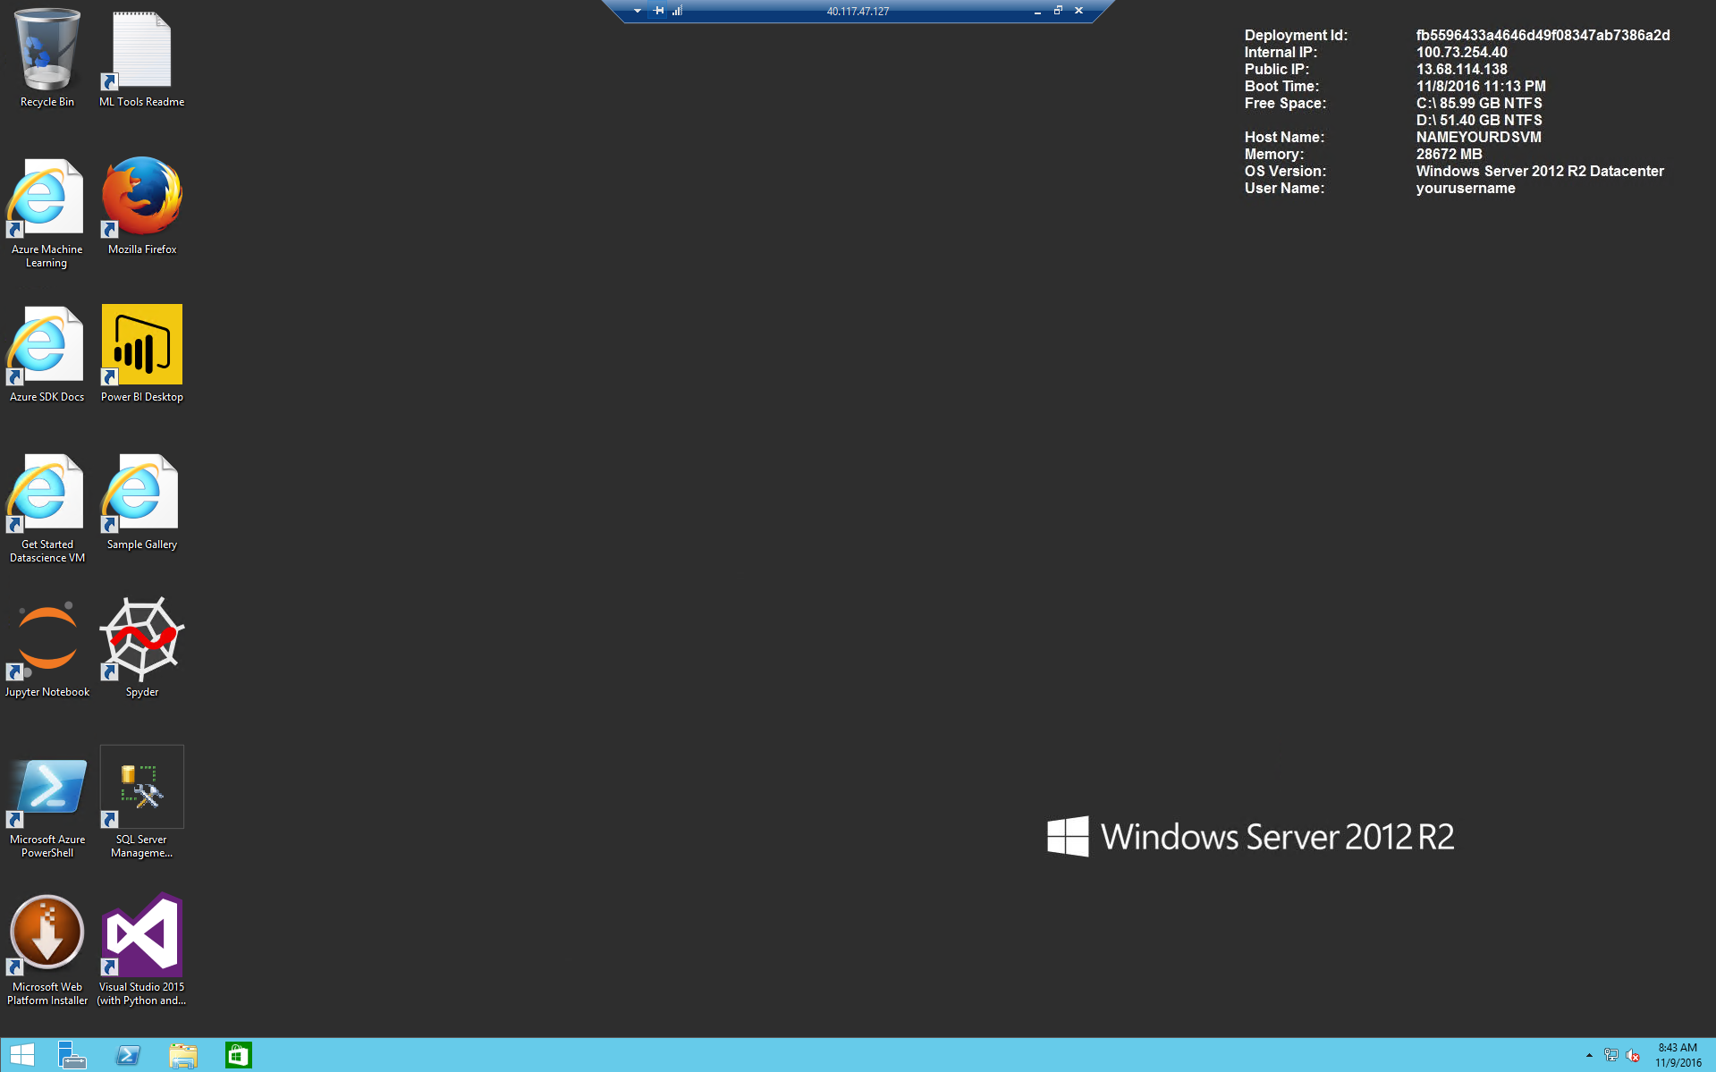
5. Check out the “Getting Started - 10 things You can do on DSVM” article by opening the shortcut link on the desktop, or going directly to <http://aka.ms/dsvmtenthings>.   
   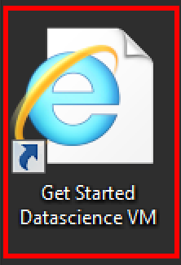 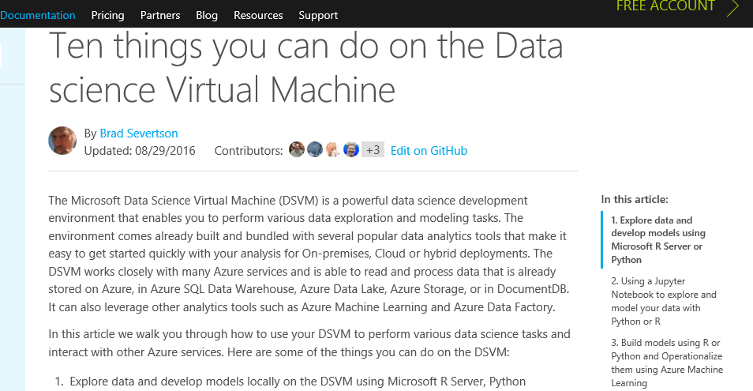
6. Open Visual Studio and sign in.  
   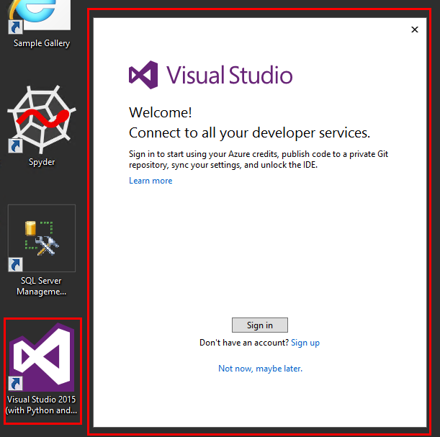
7. As you can see AI Tools for Visual Studio are pre-installed  
   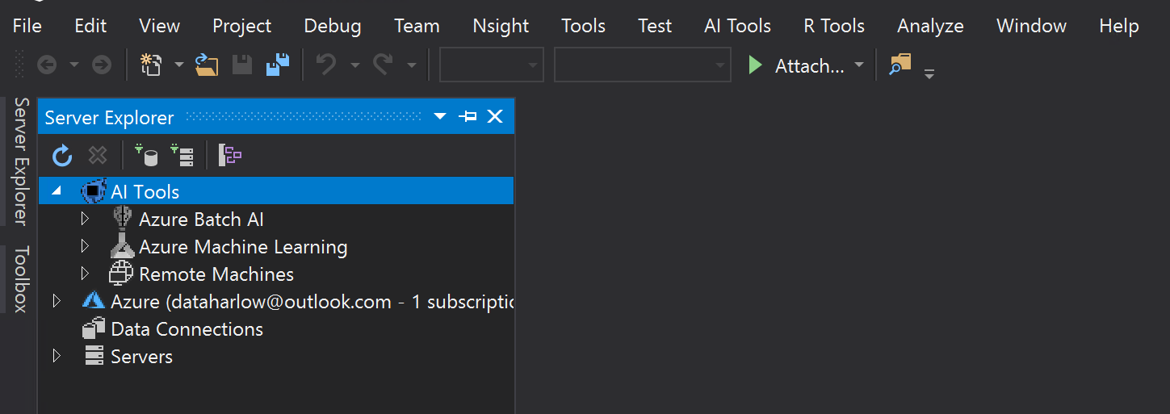
8. You may need to upgrade AI Tools.

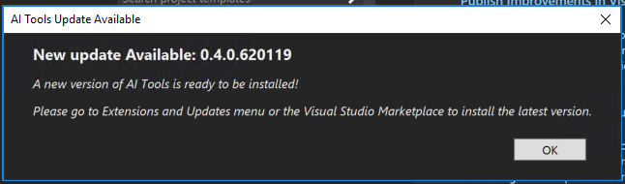

You might need to uninstall AI tools under Installed before you can install the update

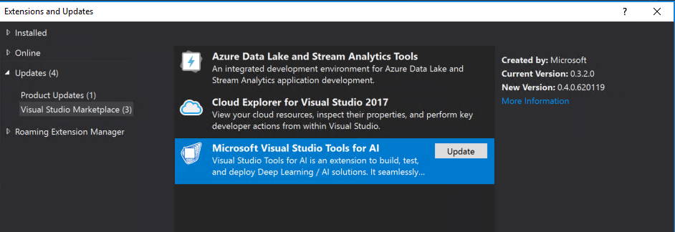

# Deploying a Deep Learning Virtual Machine – Using the Azure portal

(NOTE: Azure Pass and Free Azure Subscriptions might not have access to GPU VMS – Please proceed to the next section to deploy a Linux DSVM CPU VM to use in place of GPU VM – See 34)

1. Go to <http://portal.azure.com>  
   Sign in with your Azure subscription credentials and you will see the portal dashboard.  
   
2. Click on Create a resource  
   
3. Type in **deep learning** in the search bar and then press Enter. You may also click on the suggestions, but if you just search for deep learning, you will see all options in the results.  
   
4. The search results should look like the figure below. Choose the **Deep Learning Virtual Machine**  
   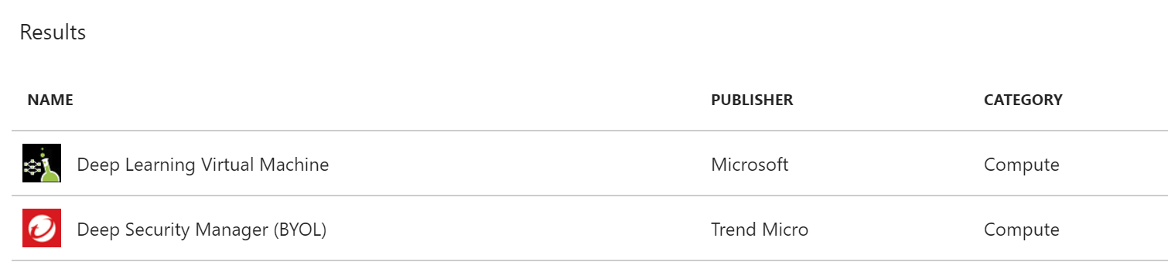
5. Once you chose the VM version, you will see the next frame that has some specific information. You can click ‘Create’ to start the creation process. The deployment model for DLVM is pre-set to be Azure Resource Manager (ARM). You may need to click on Want to deply programmatically? Get started 🡪 to enable ARM deployments

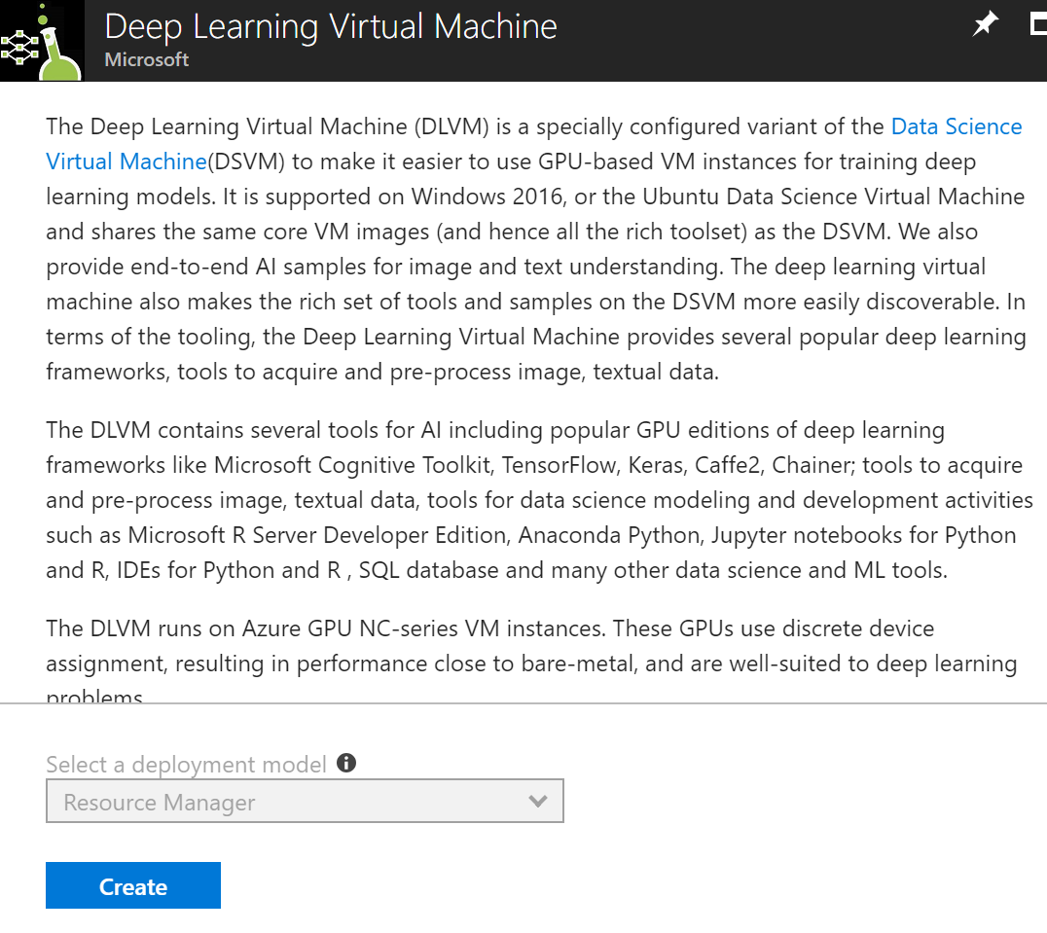

1. Once you press ‘Create’ you will arrive at the ‘Create Deep Learning Virtual Machine’ frame. Here, you will be going through 4 stages of creation: Basics >> Settings >> Summary >>Buy.

Select an OS Type of Linux and region with NC Series GPUs (East US, South Central US, or West US 2)

Refer to <https://azure.microsoft.com/en-us/global-infrastructure/services/>

At the time of writing this document NC Series were not available in Southeast Asia. Australia East did have NC Series but my Azure Pass subscription did not have access to this region.  
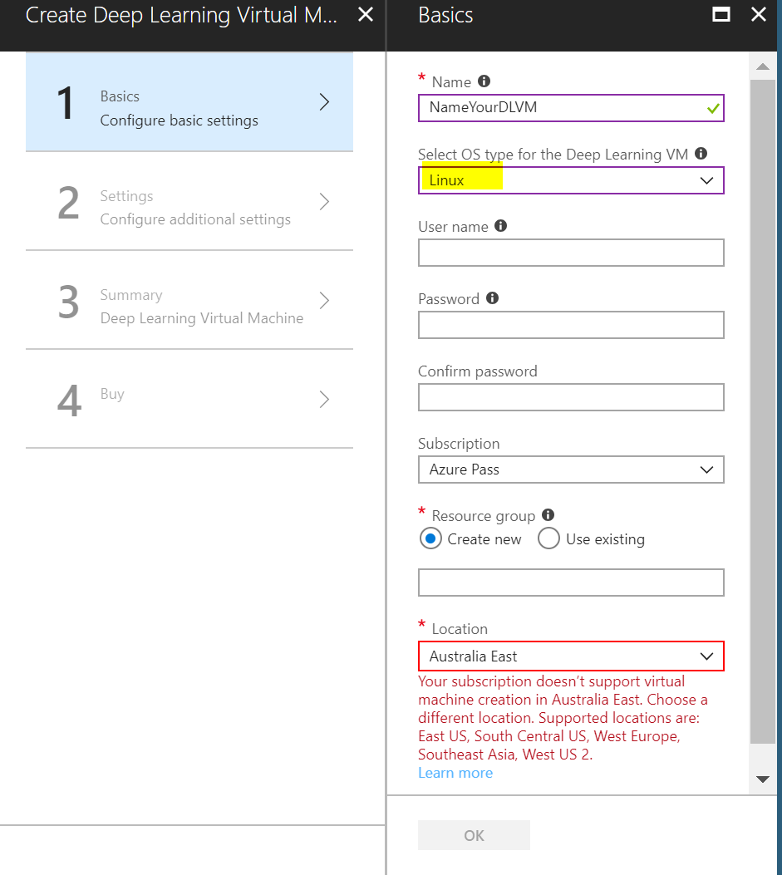

1. On the ‘Size’ tab, select the desired configuration of the machine that you want. Since the purpose of this instance is ‘Deep Learning’, we recommend choosing an instance size (like an NC6) with 6 or more vcpus and 112GB or more of RAM. You can scale the instances up or down as per your requirement. Additionally, you can also shut down and deallocate the instances when not in use. This may be done programmatically as well. Click ‘Select’ to proceed to the ‘Settings’ tab. 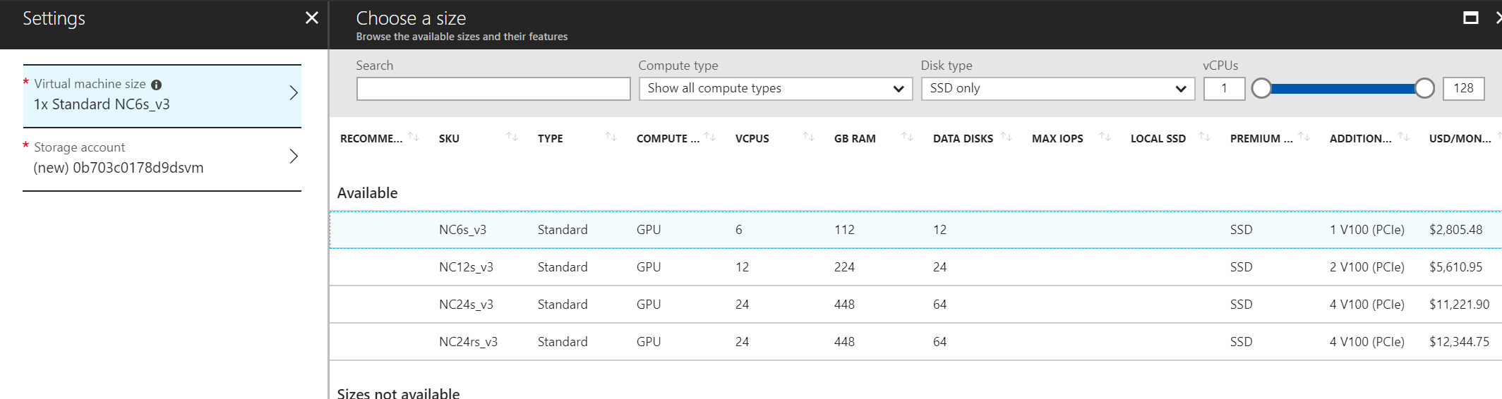
2. On the Summary tab your Azure Pass may fail validation because you have no quota for GPU cores

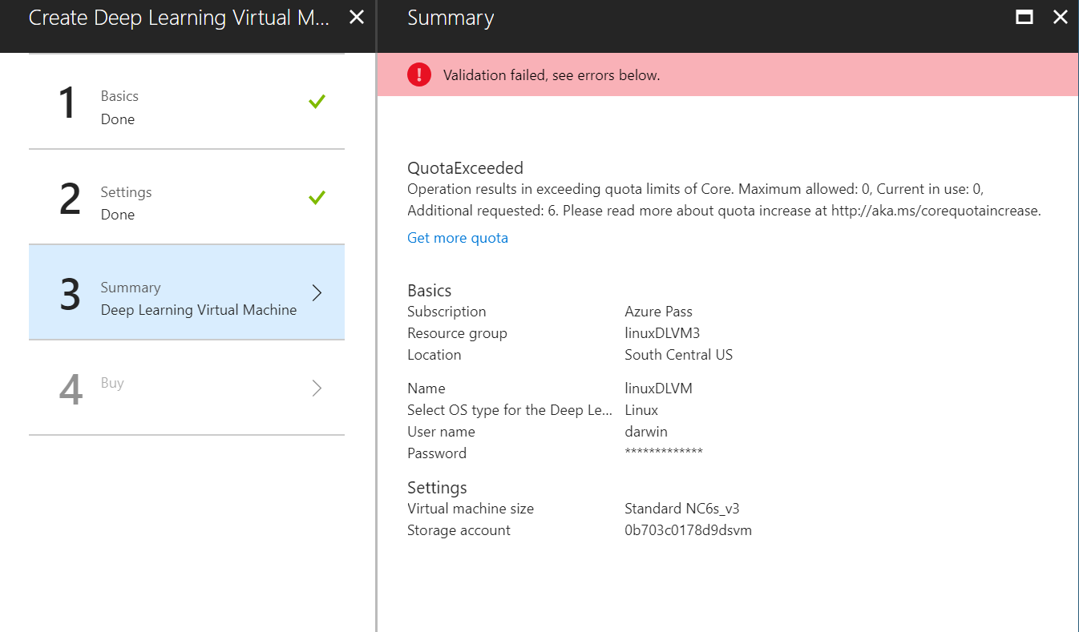

(NOTE: Azure Pass and Free Azure Subscriptions might not have access to GPU VMS – Please proceed to the next section to deploy a Linux DSVM CPU VM to use in place of GPU VM – See 39 below)

1. The Summary tab is mostly for review. Do verify the details that you have specified in the previous steps and that you have access to GPUs. Click OK to proceed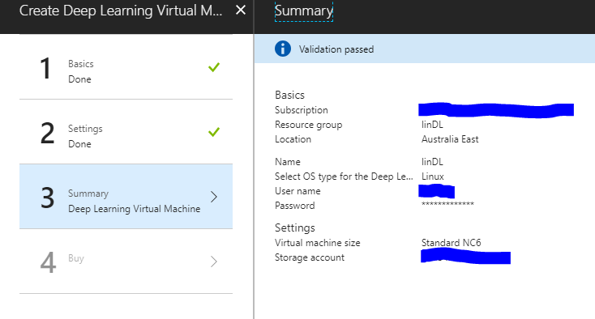
2. Check the terms of use and click Create

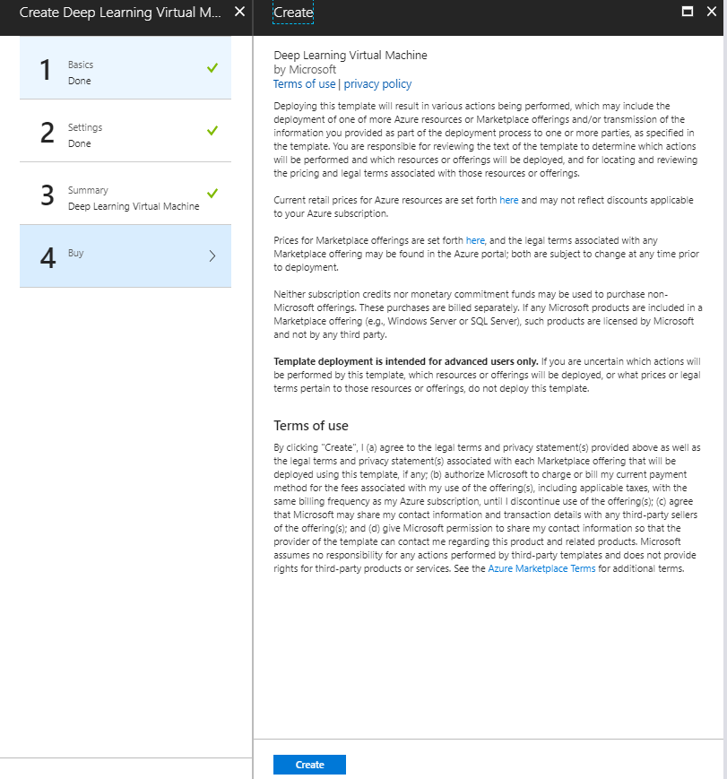

1. Once you click ‘Create’, you will be taken back to the portal dashboard and a new tile will show up like the figure below. This will read, “Deploying Data Science Virtual Machine”. Your DSVM is now being provisioned along with its related resources. This process will take approximately 5 minutes.  
   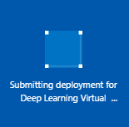
2. Once complete (after about 5 minutes) you will see a notification on the top right that reads “Deployment Successful” and your tile will change to the previously specified name for your DSVM.  
    

# Deploying a Linux Data Science Virtual Machine – Using the Azure portal

1. Go to <http://portal.azure.com>  
   Sign in with your Azure subscription credentials and you will see the portal dashboard.  
   
2. Click on Create a resource  
   
3. Type in **data science** in the search bar and then press Enter. You may also click on the suggestions, but if you just search for deep learning, you will see all options in the results.  
   
4. The search results should look like the figure below. Choose the **Data Science Virtual Machine for Linux (Ubuntu)**  
   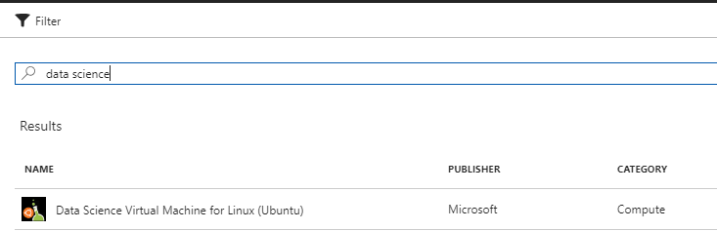

42. Once you chose the VM version, you will see the next frame that has some specific information. You can click ‘Create’ to start the creation process. The deployment model for DSVM is pre-set to be Azure Resource Manager (ARM). You may need to click on Want to deply programmatically? Get started 🡪 to enable ARM deployments

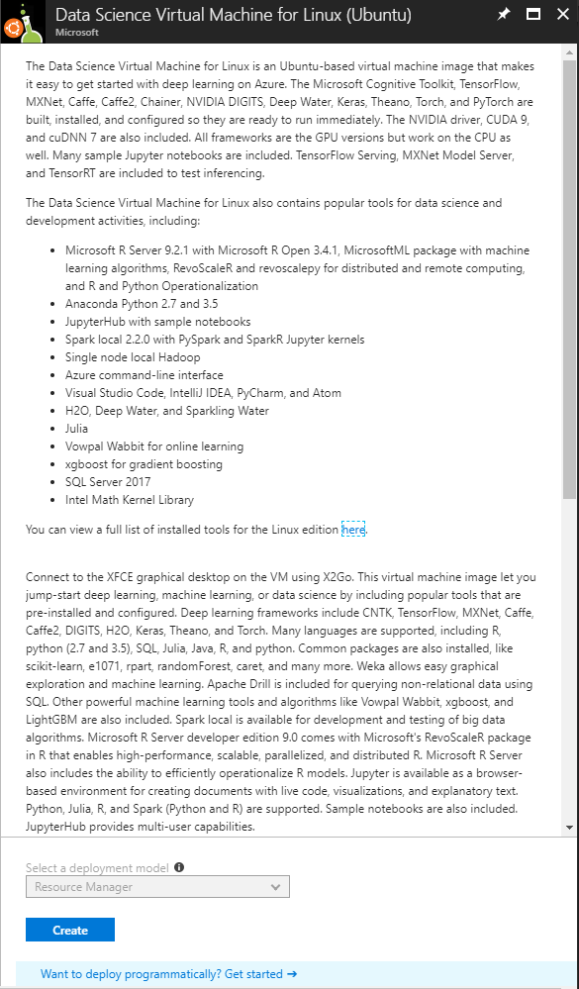

43. Once you press ‘Create’ you will arrive at the ‘Create Virtual Machine’ frame. Here, you will be going through 4 stages of creation: Basics >> Size >> Settings >> Summary. Choose Authentication type: Password. Click OK

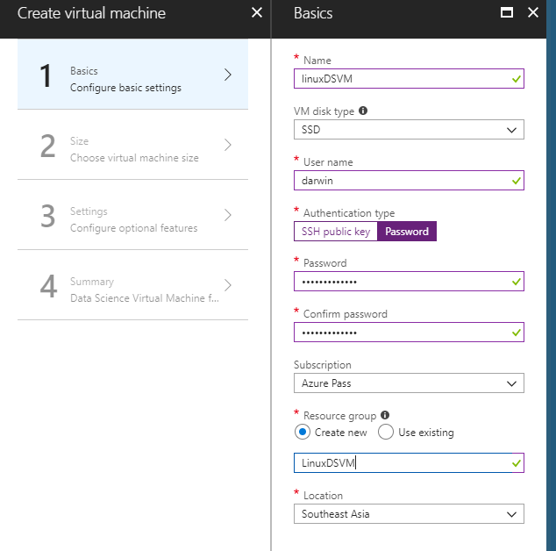

44. Choose a VM with at lease 4 VCPUS and 14+ GB RAM (i.e. D4s_v3). Click OK

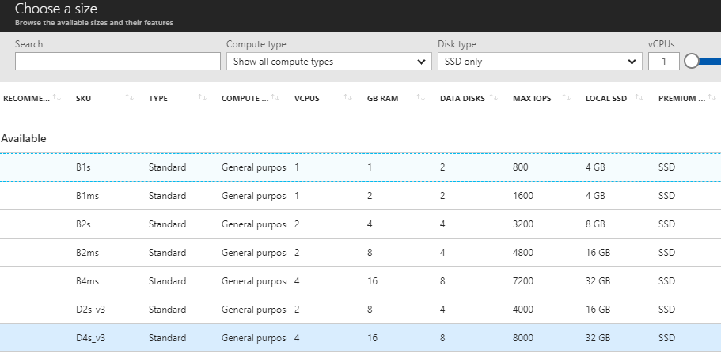

45. Take the default for Settings. On any of the VMs you might want to configure Auto-shutdown to manage the spending in your subscription. Click OK

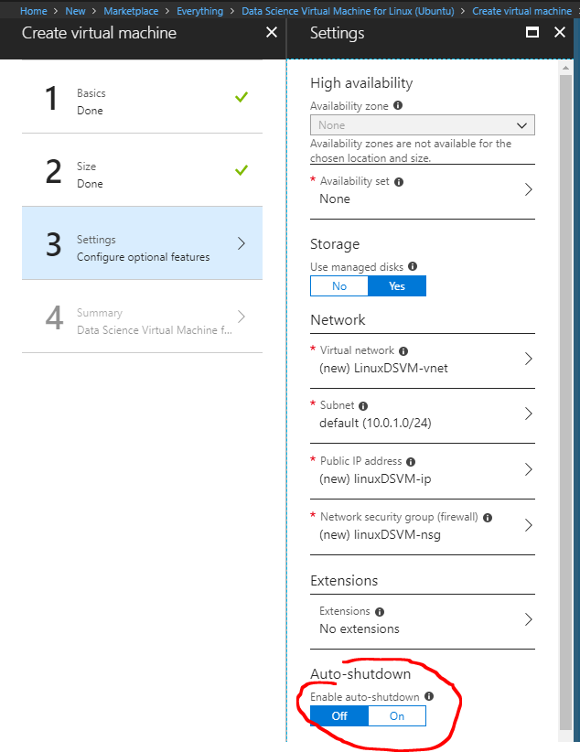

46. Read the Summary. Check Terms of use. Click Create.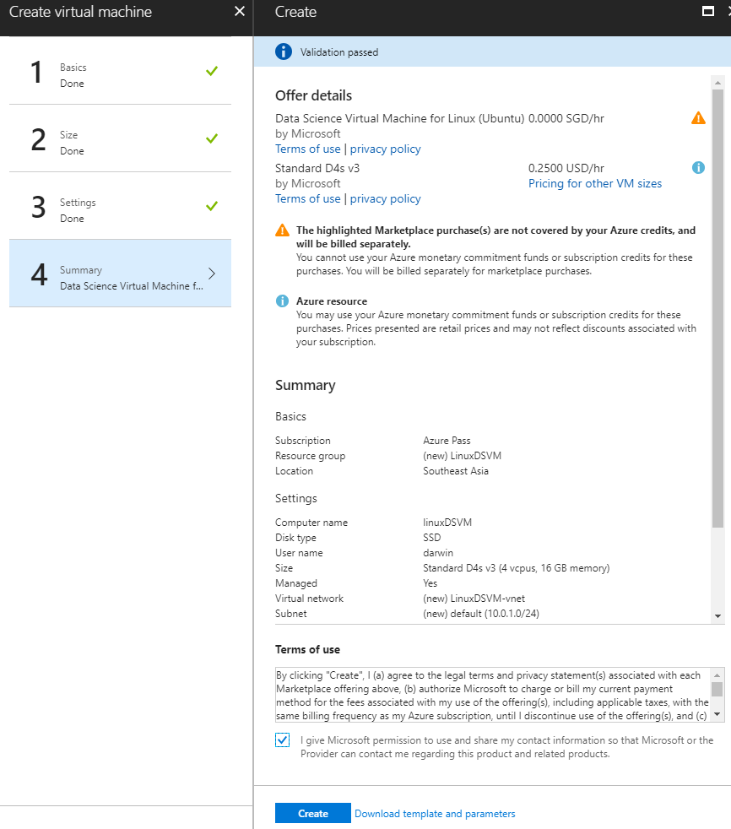

1. Once you click ‘Create’, you will be taken back to the portal dashboard and a new tile will show up like the figure below. This will read, “Deploying Data Science Virtual Machine”. Your DSVM is now being provisioned along with its related resources. This process will take approximately 5 minutes.  
   
2. Once complete (after about 5 minutes) you will see a notification on the top right that reads “Deployment Successful” and your tile will change to the previously specified name for your DSVM.  
    

# Connecting to Deep Learning VM or Linux DSVM – Using SSH

49. You can now Click on the Tile for your DLVM or DSVM. This will open the frame for your VM and give you numerous options, links and charts with dashboards showing the per minute diagnostics etc. if you had turned them on. You can now Click on the “Connect” button to get the SSH information

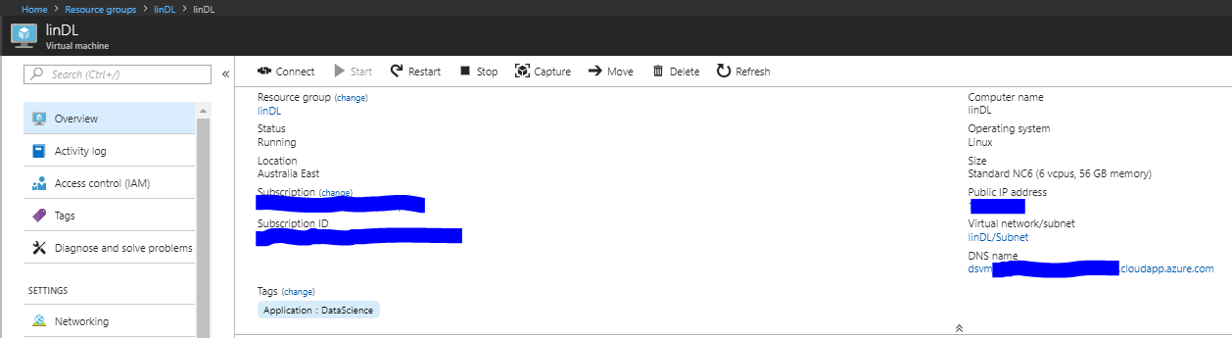

50. Copy the Login using VM local account

Something like **ssh username@dsvmdl.australiaeast.cloudapp.azure.com**

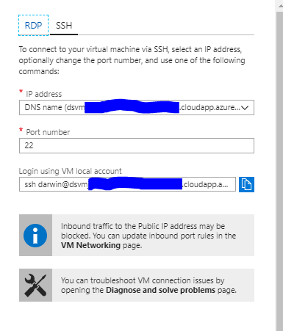

1. Open Git Bash and paste the ssh connection into the command line and hit Enter

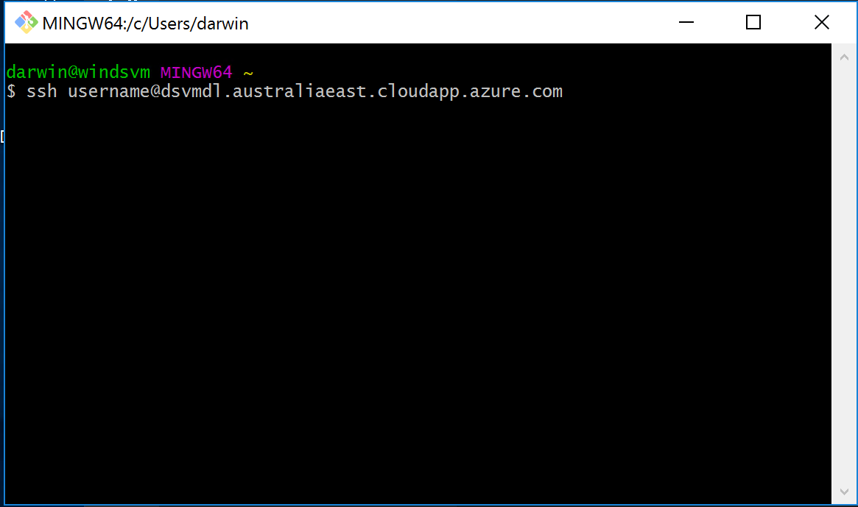

Enter yes hit Enter then enter the password and hit Enter, You are logged in.

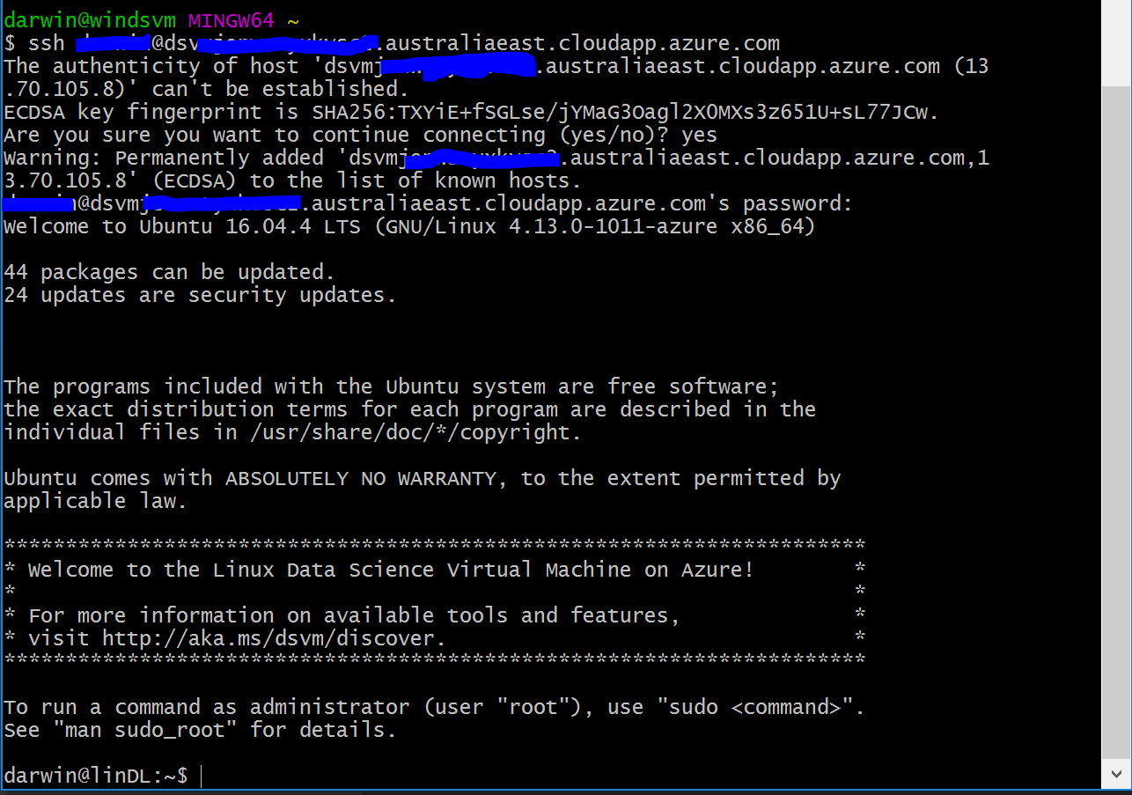

Let’s look and see what is on this server

**pwd** Enter to find the current path  
**ls** Enter to list directories  
**cd notebooks** Enter to change directory  
**ls** Enter to list the directories and file in the notebooks directory

We will return to this later after we use Jupyter Hub, Visual Studio, and VS Code to access the file system as well

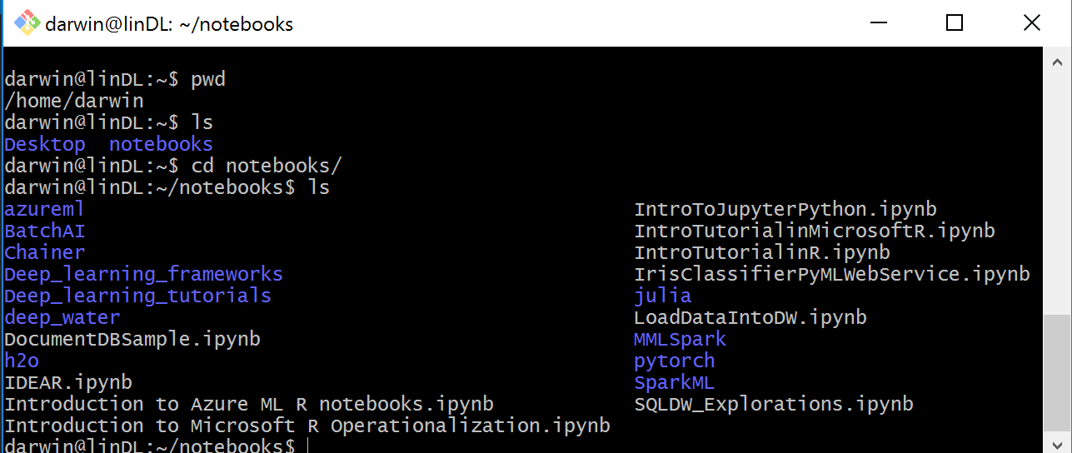

# Configure Remote Machines in Visual Studio

1. Add the Linux Deep Learning VM or DSVM as a Remote Machine by right clicking on Remote Machines. Enter the configuration information from the Azure portal and click OK

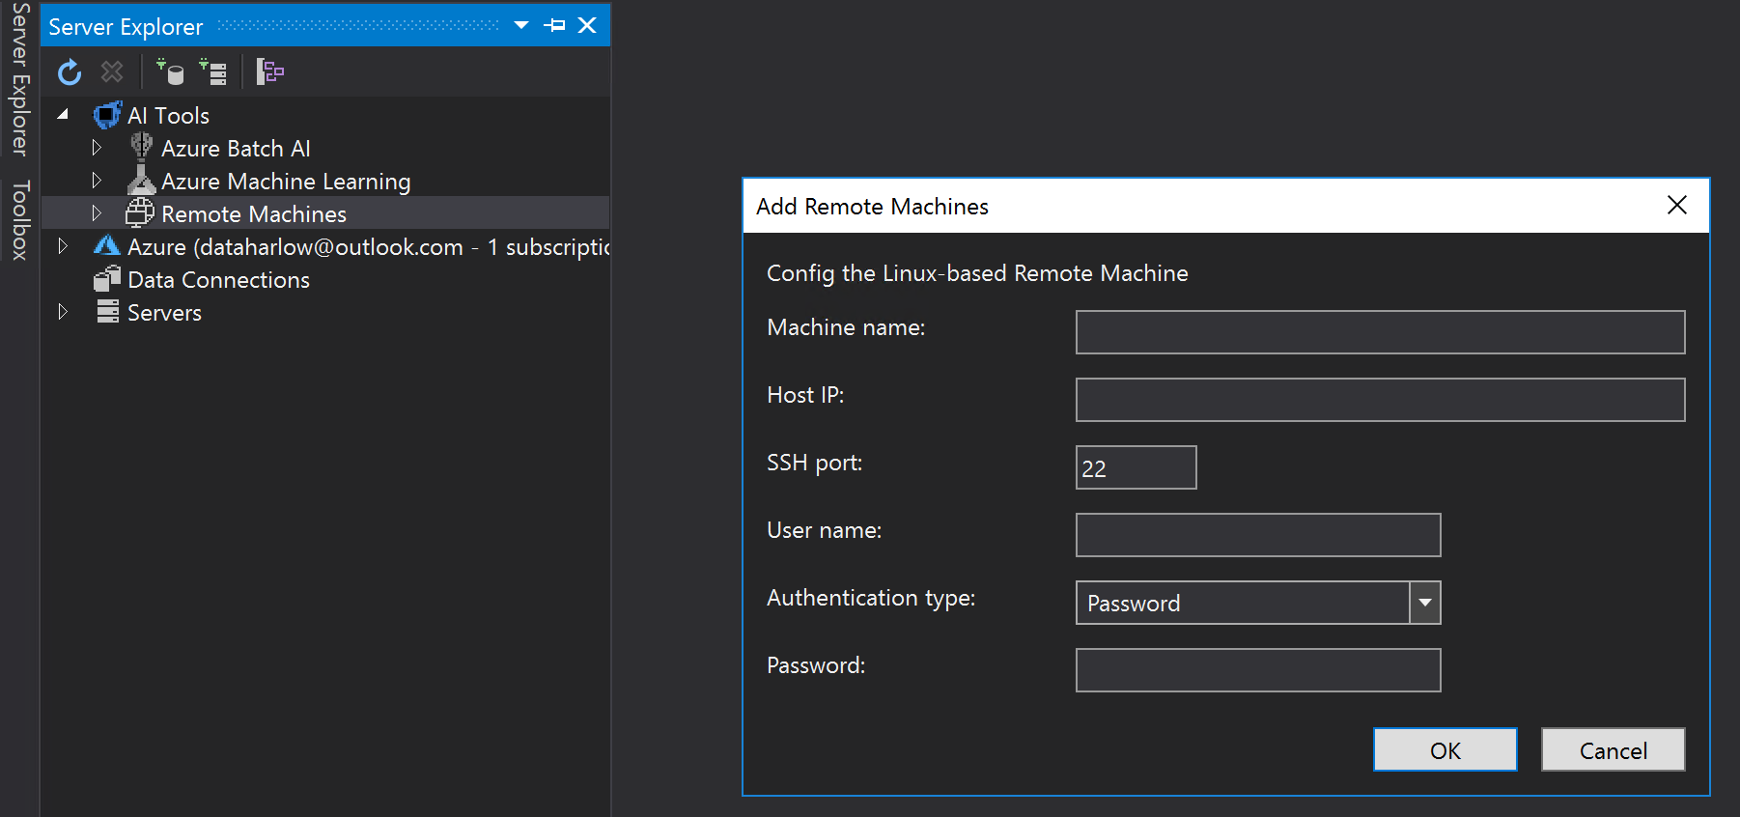

Double-click on the Storage to access storage on the Remote Linux DLVM or DSVM

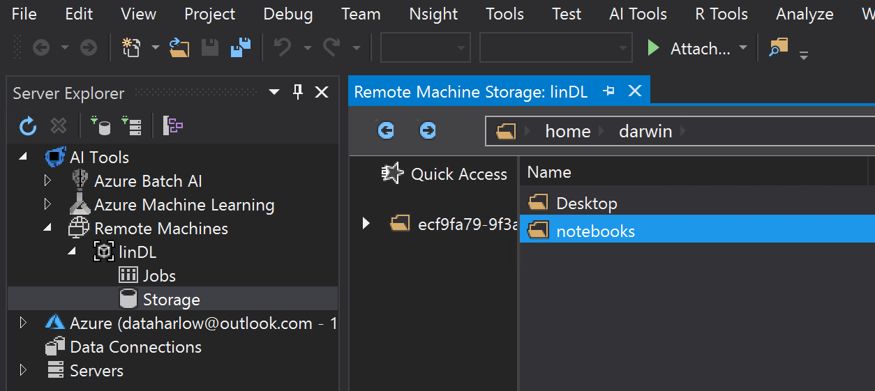

1. Create a new folder called **currency_detector** in the notebooks folder

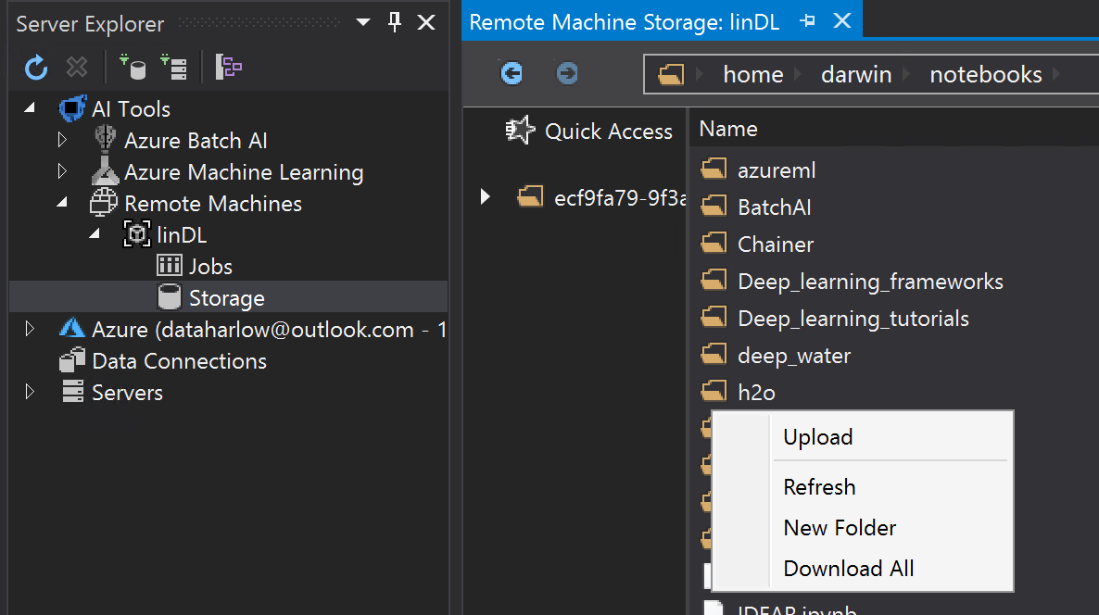

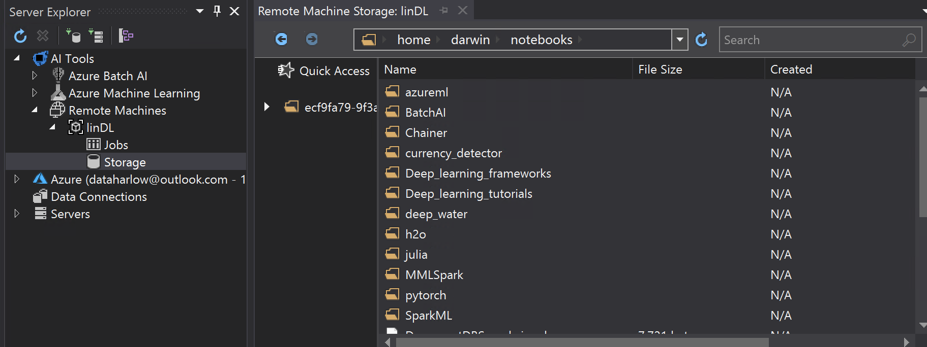

# Login to Jupyter Hub on the Deep Learning VM

1. Open the Firefox browser on the Windows 2016 DSVM and enter the following URL:

https://<DNSname>:8000/hub/login or https://<PublicIP>:8000/hub/login

You can find the DNSname or Public IP in the Azure portal for your deployed Linux DLVM or DSVM

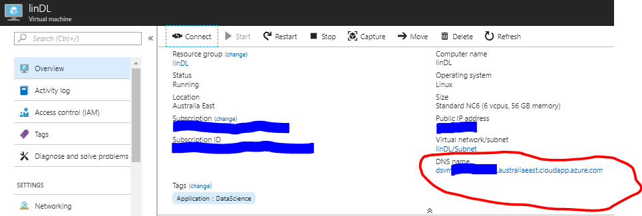

You will get this warning, so click the **Advanced** button and then **Add Exception** button

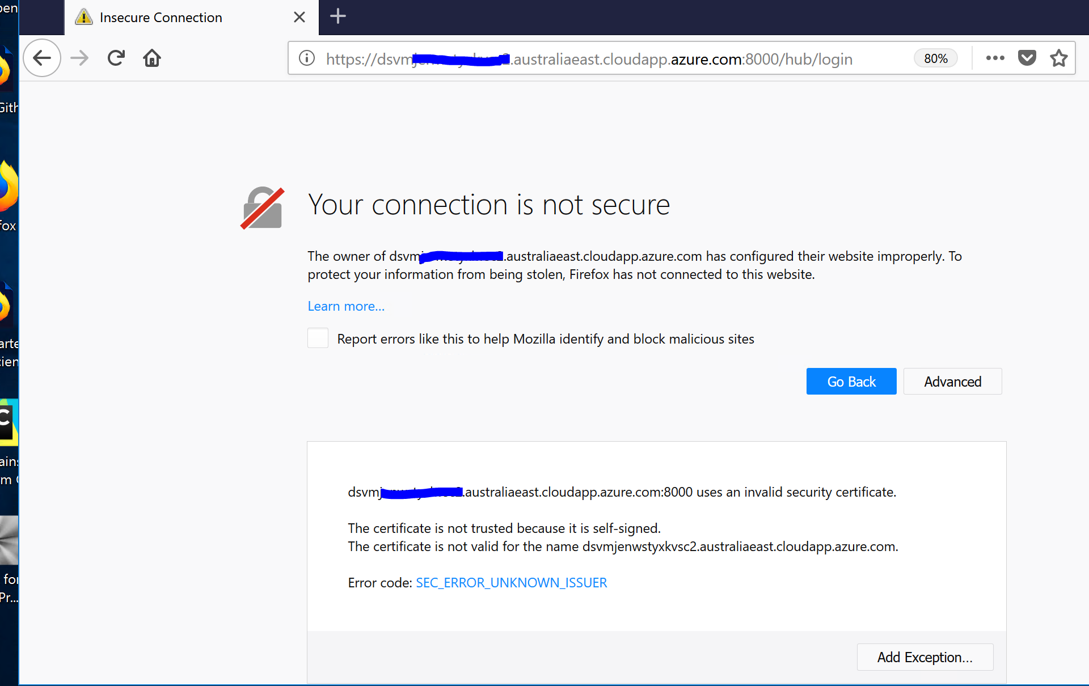

Confirm Security Exception

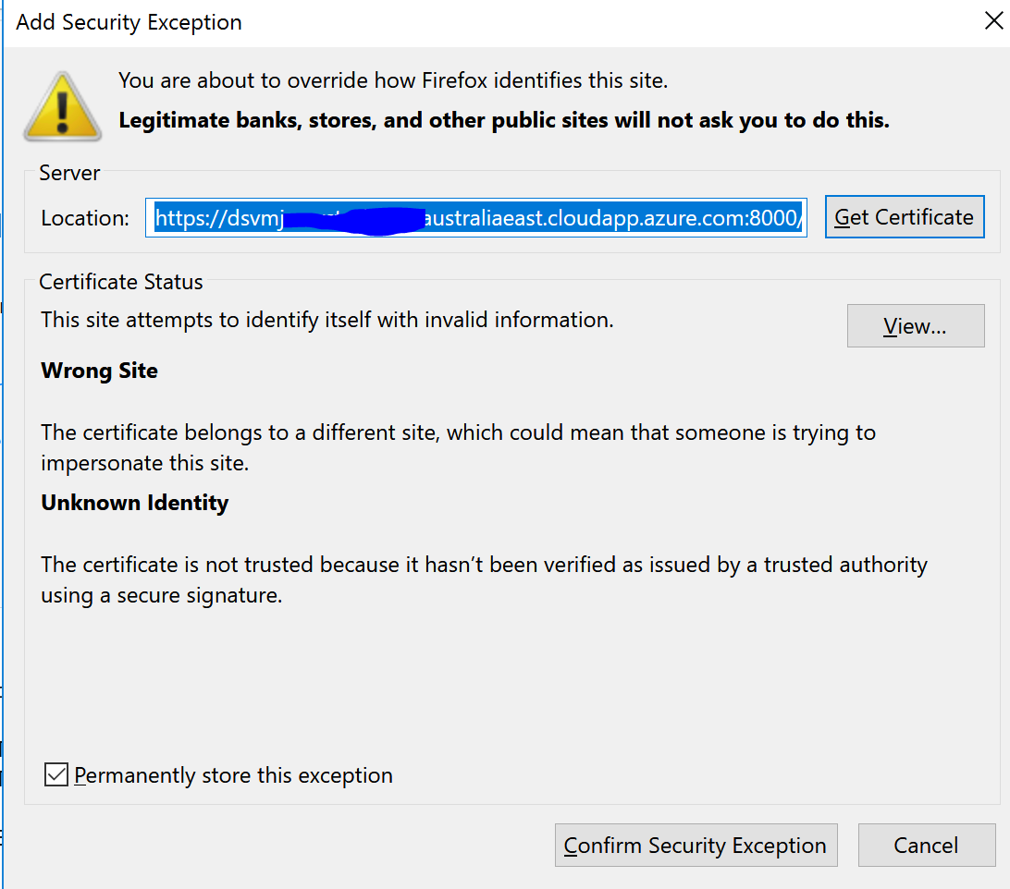

1. Login to Jupyter Hub with the Username and Password for the Linux DLVM or DSVM

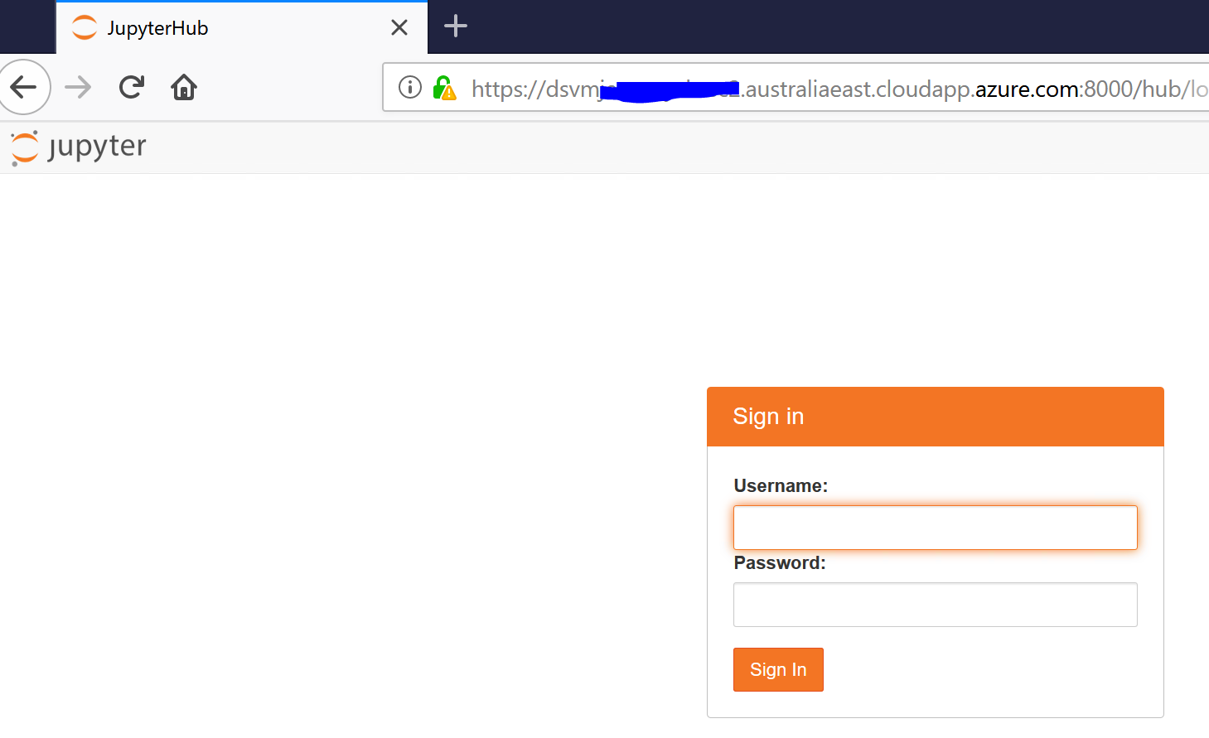

Click on Start My Server

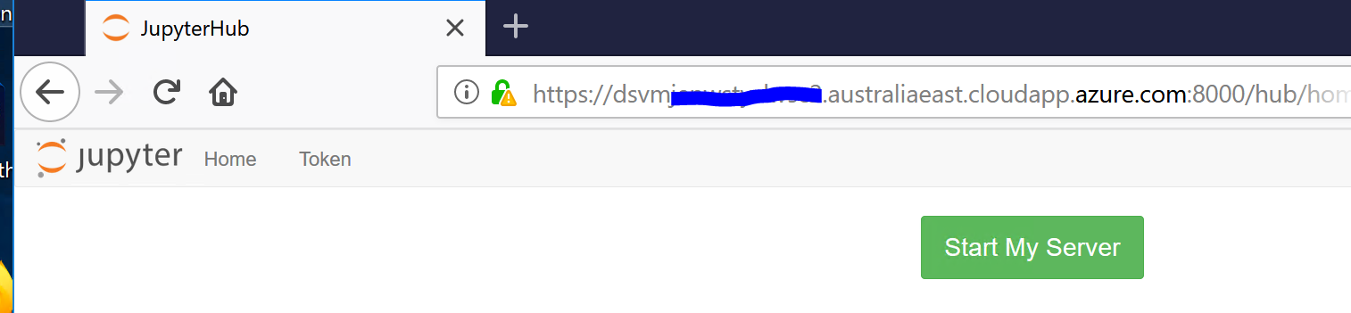

You can now see the folders and notebooks we looked at earlier in Git Bash and Visual Studio

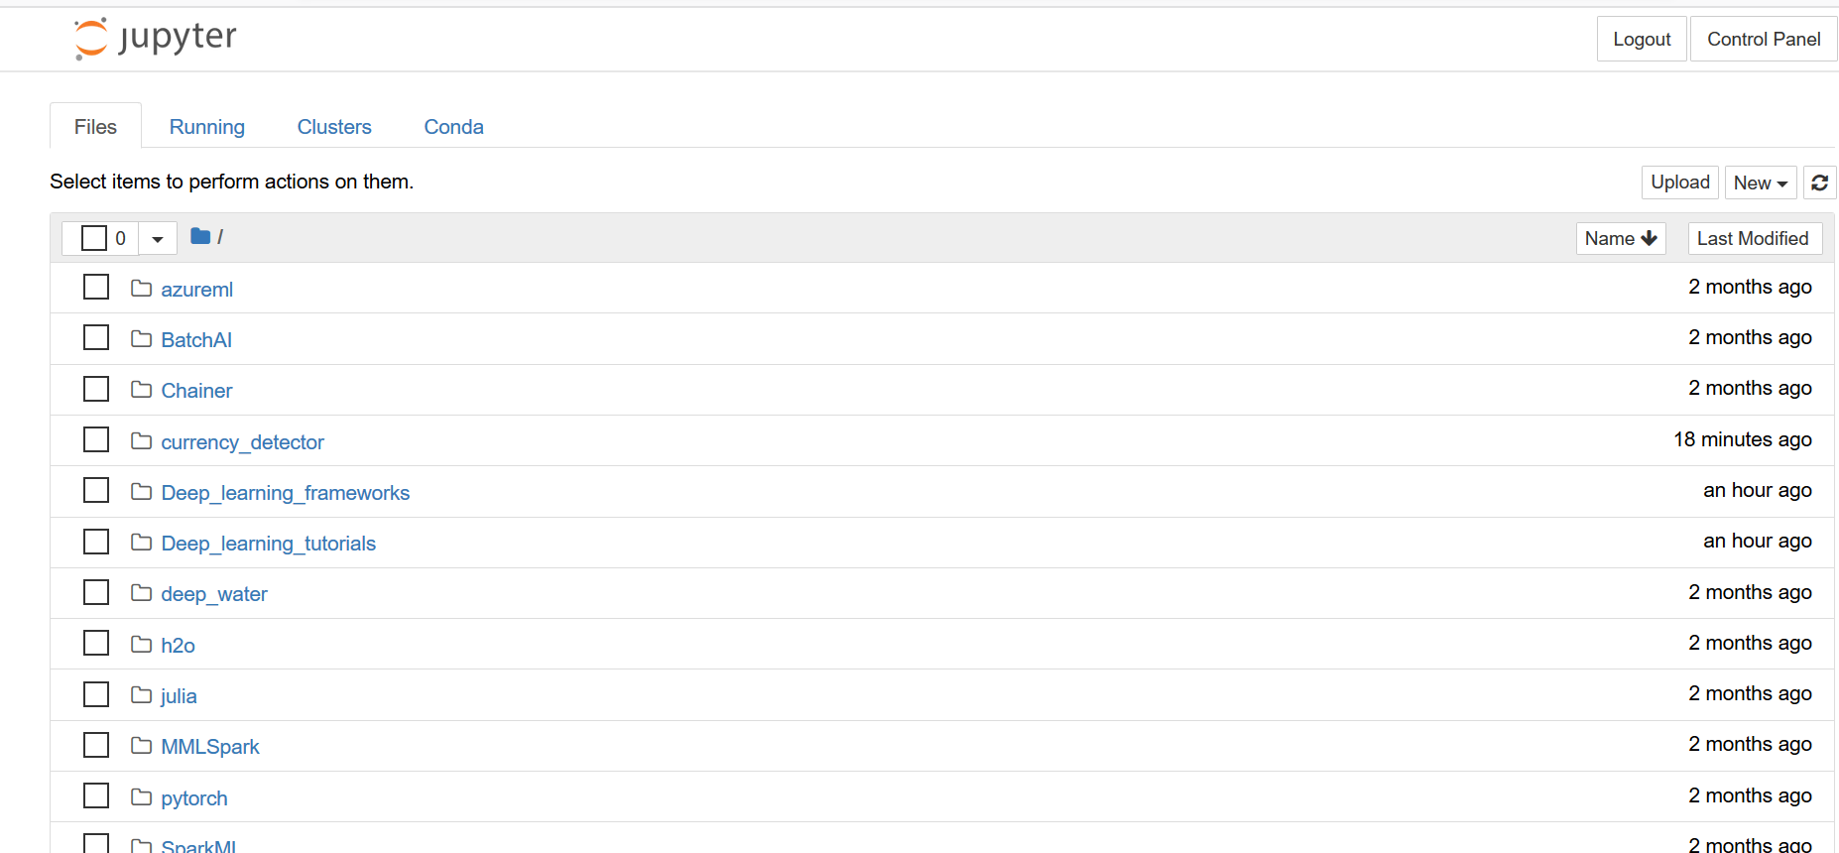

# Clone the GitHub Repository for [SeeingAI-Currency-Detection](https://github.com/xiaoyongzhu/SeeingAI-Currency-Detection)

1. Go to the GitHub repository <https://github.com/xiaoyongzhu/SeeingAI-Currency-Detection>

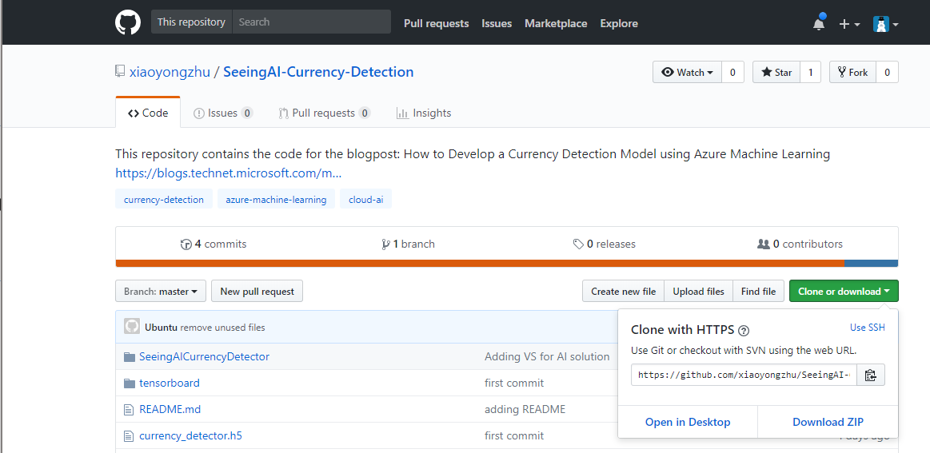

Copy the web URL and run the following cmd in Git Bash on either the Windows DSVM or the Linux DLVM or DSVM

git clone <https://github.com/xiaoyongzhu/SeeingAI-Currency-Detection.git>

I am going to do this on the Window DSVM and then use Visual Studio to copy the files, but lots of options here from terminal and GUIs. I make a directory, cd into it and run my git clone.

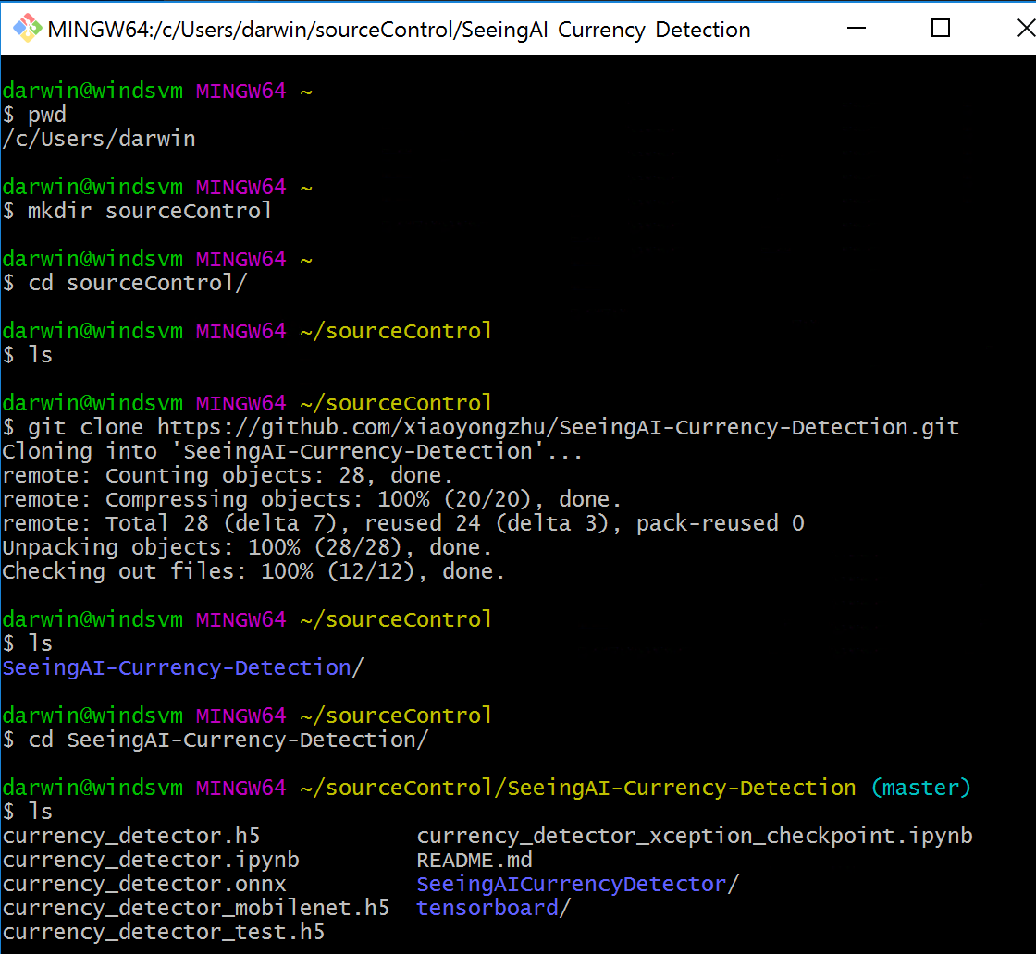

# Upload Notebooks from git clone into the **currency_detector** folder

1. Back in Visual Studio go into the currency_detector folder and right click and choose Upload

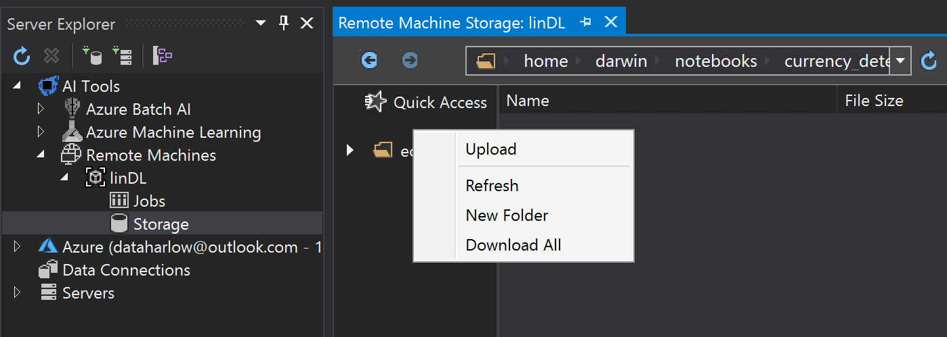

Navigate to where you just cloned the GitHub repo, choose the two notebooks and click Open

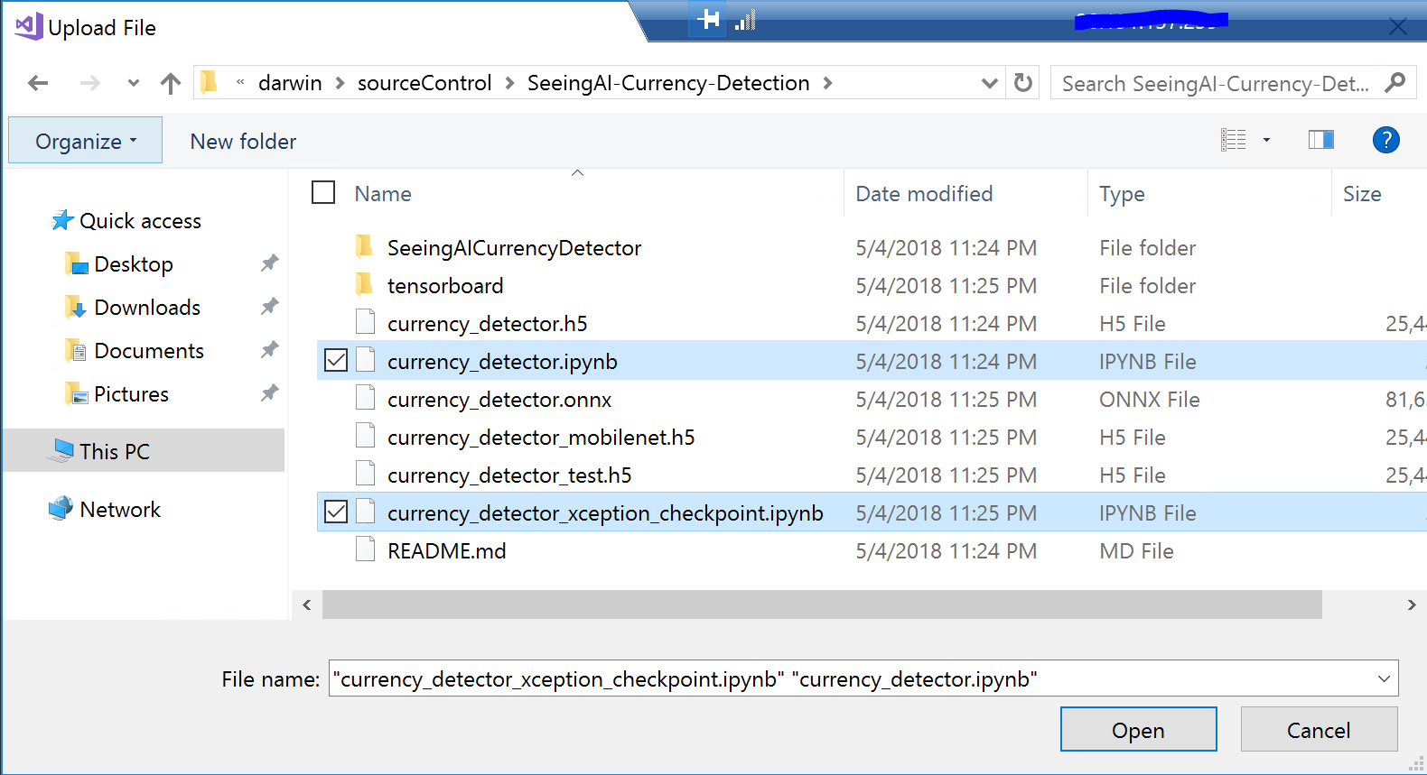

The notebooks are now uploaded

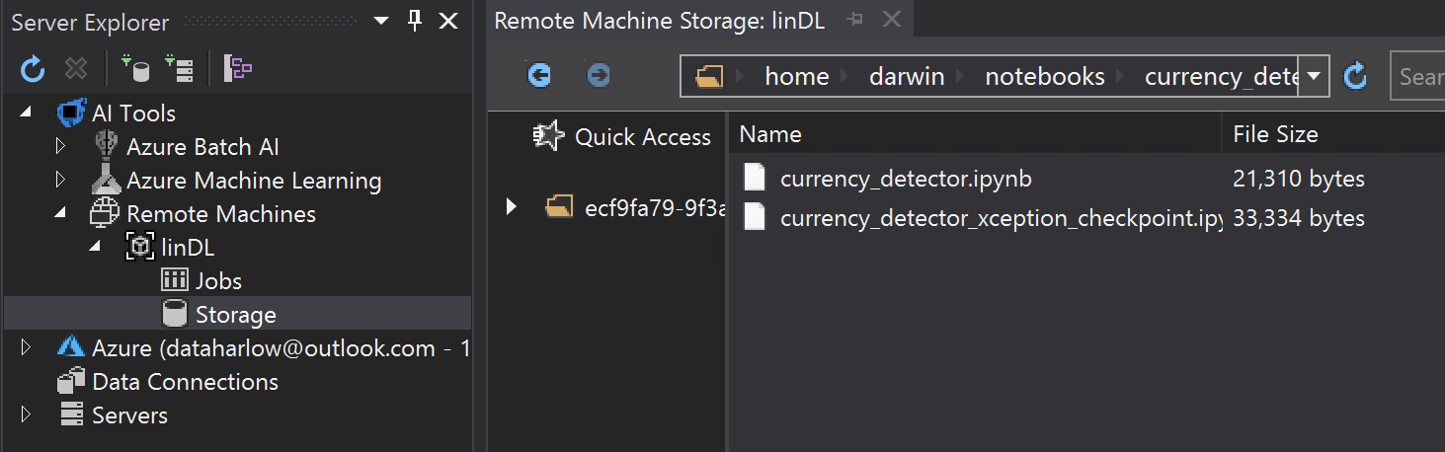

# View and Open the notebook in Juypter Hub

1. The notebooks are now available in Jupyter Hub

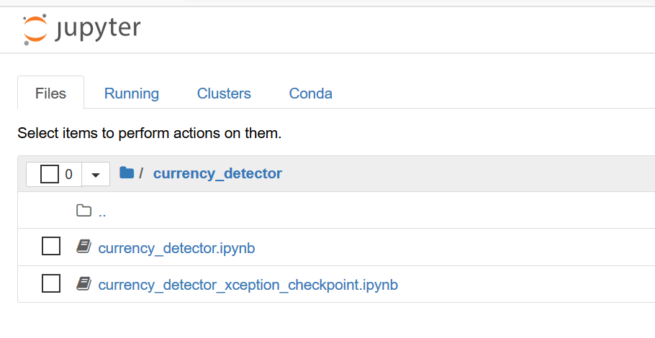

1. Open currency_detector.ipynb and have a look at it

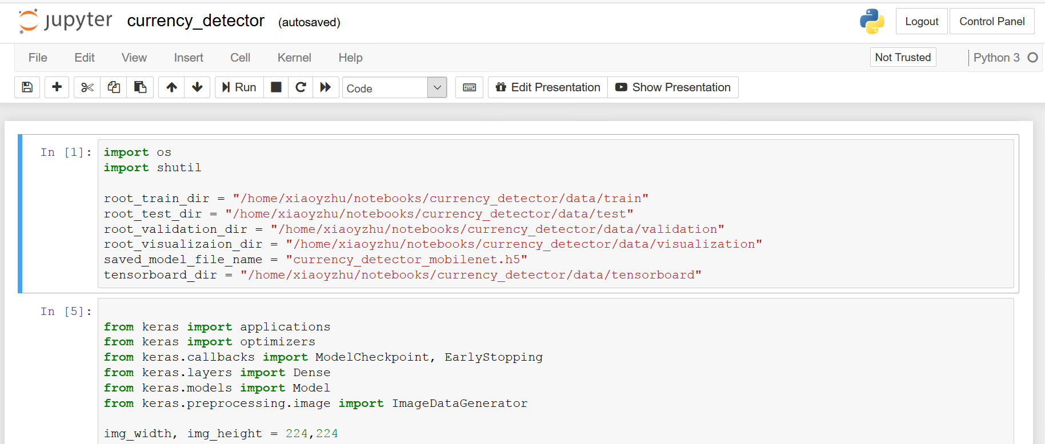

1. Edit the first cell in the notebook to have your user on your DLVM or DSVM. In my case I change the user in the path to **darwin** vs the committer of the GitHub Repo **xiaoyzhu**

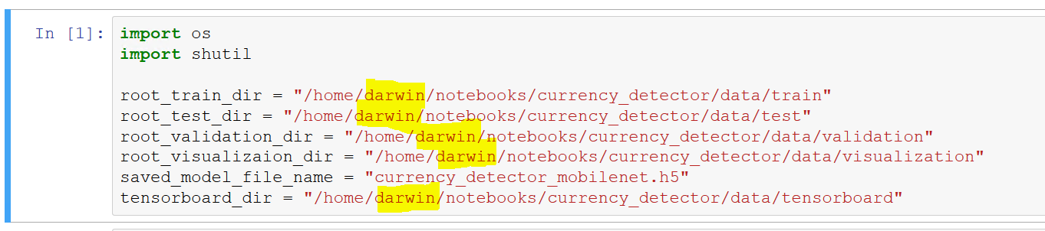

# Download images from Azure Blob and upload to Linux DLVM or DSVM

1. Use Microsoft Azure Storage Explorer to download the images from blob store to the Windows DSVM  
     
   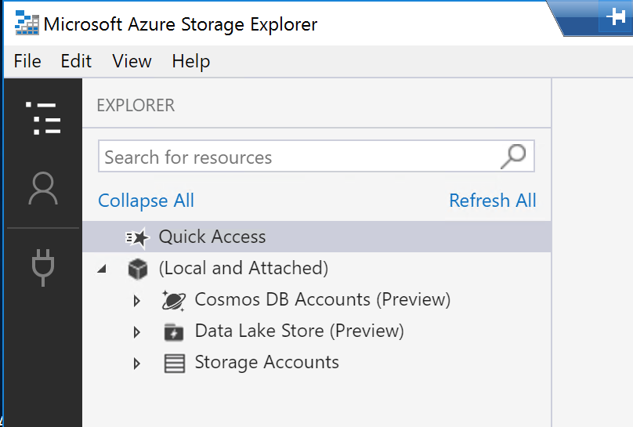  
     
   Click on the connection plug icon and choose **Use a storage account name and key.** Click Next

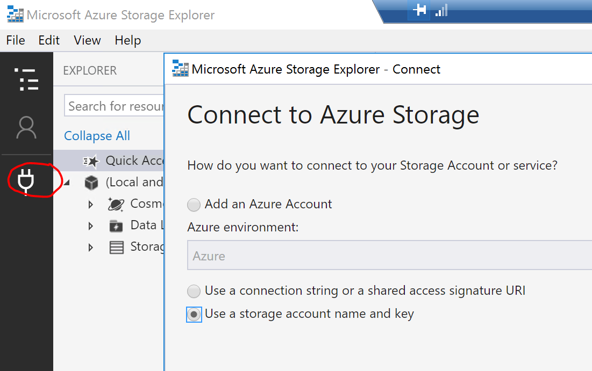

1. Enter the following Account name and Account key. Click Next. Click Connect

Account name: cdhol

Account key: Sc4E1mKUAfndnSx5xzAmyzxVW9e7tmbjTGsWnktOsmaX/bYD70h1aMyHbJtHINNReYwYq9ohpDLCJCR+yBuurw==

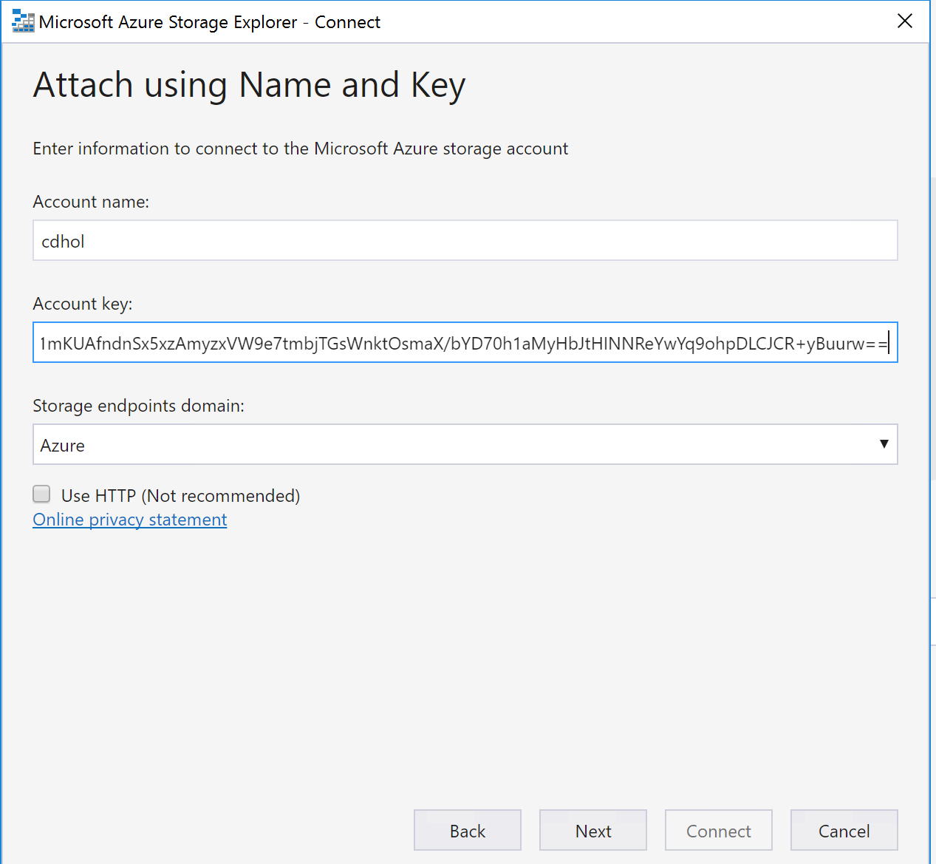

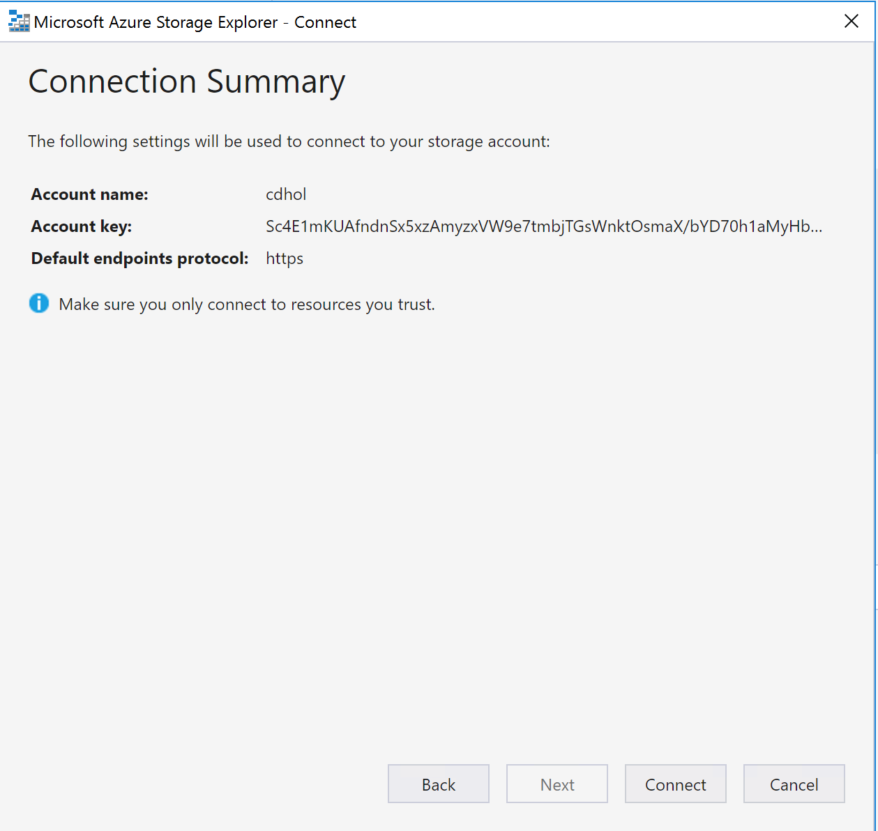

Click on the currencydetector container and click Download to download the data folder and the folders in the folder (i.e. test, train, validation) to the Windows DSVM

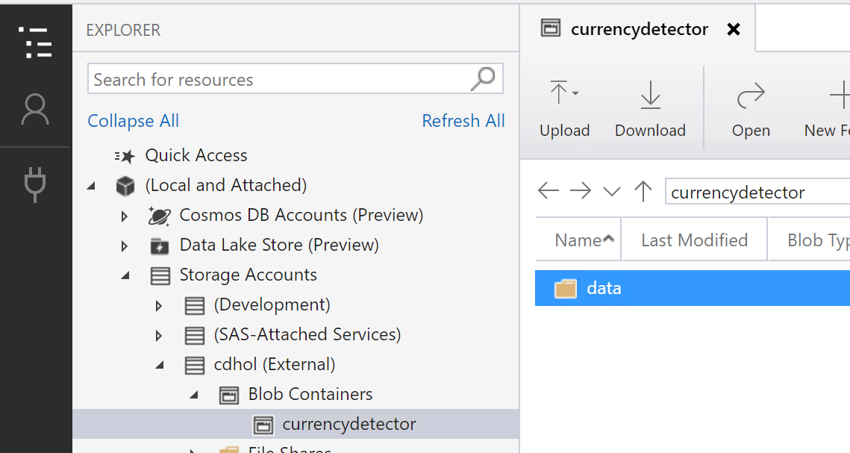

You should end-up with files like this in test, train, and validation

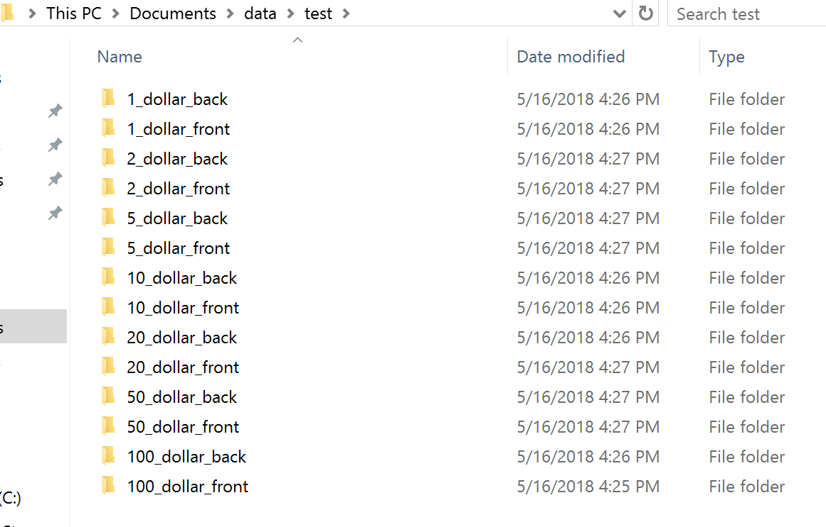

1. Use VS Code AI Tools to upload the files to the Linux DLVM or DSVM. It turns out that AI Tools in Visual Studio Code has a better upload capability at the folder level than AI Tools in Visual Studio  
     
   Open Visual Studio Code, click on the Extension icon on the left navigation panel, enter AI into search box, and install Visual Studio Code Tools for AI. When finished click Reload

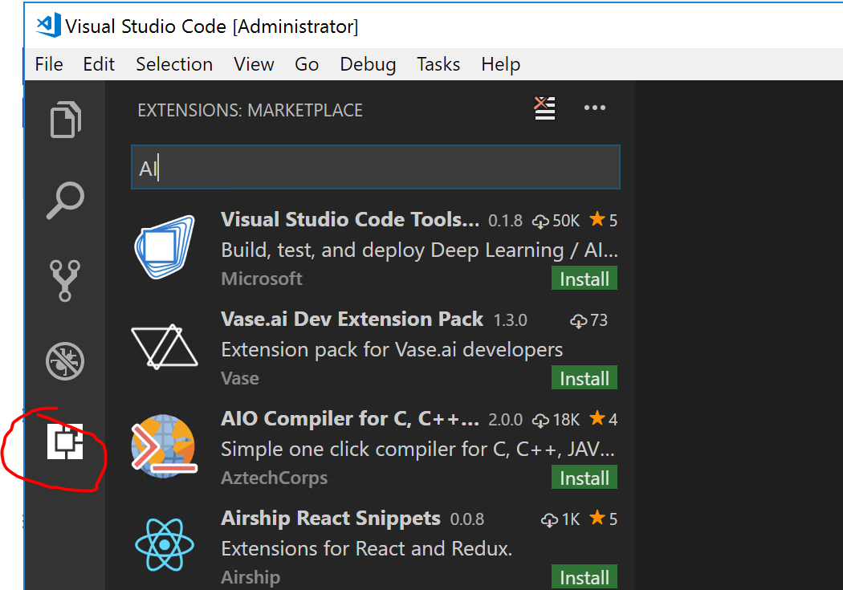

1. Right click on Remote Linux – SSH Endpoints and choose Add Configuration. Enter the IP address (get in the Azure Portal) of the Linux DLVM or DSVM, as well as the username and password and click Finish.  
     
   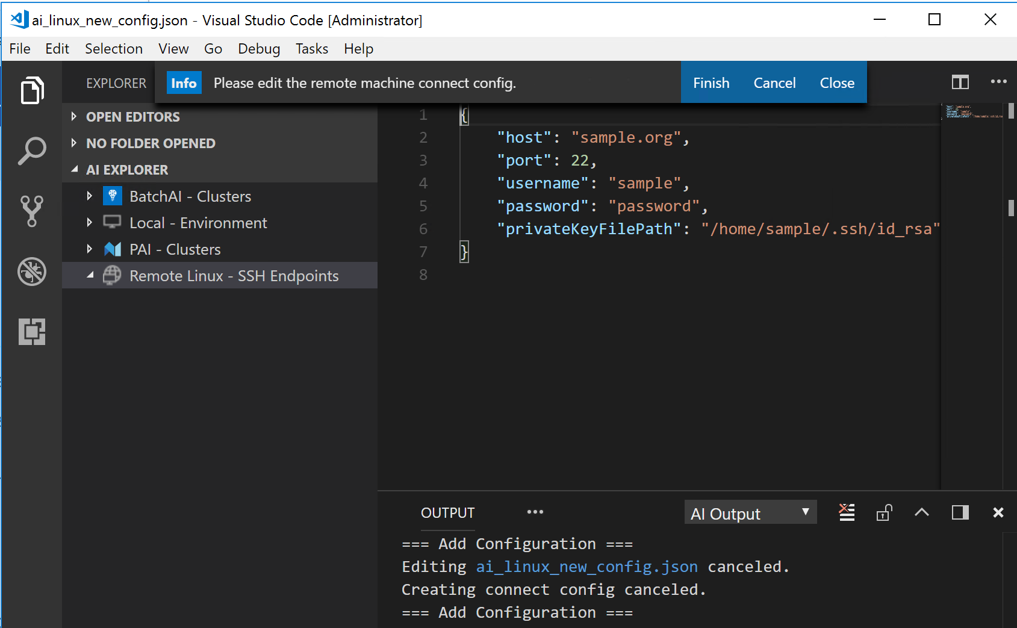
2. Right click the Remote server and choose Open Storage Explorer. Choose Home Directory  
     
   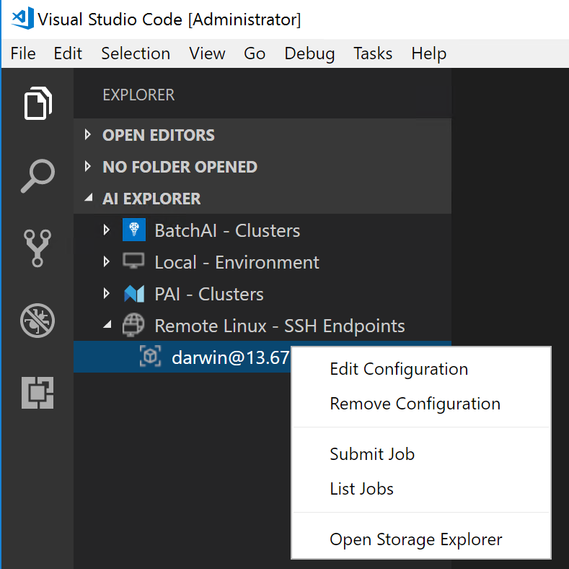

You now have a AI Storage Explorer where you can right click on the currency_detector folder and choose Upload Folder  
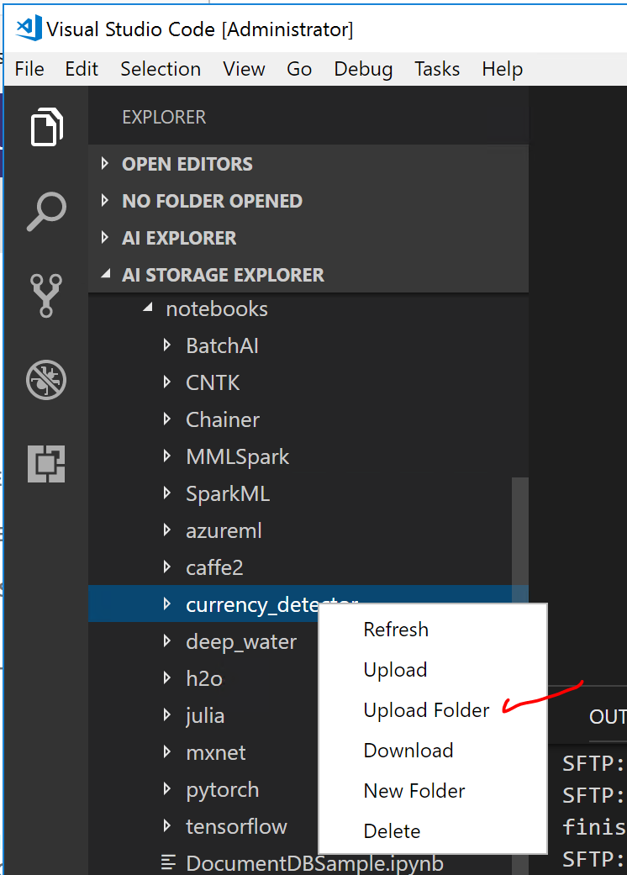

Choose the data folder that you just downloaded with Microsoft Azure Storage Explorer and choose Select Folder

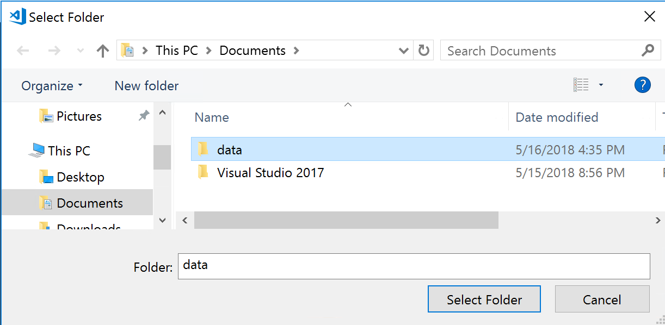

It will start SFTPing the files  
  
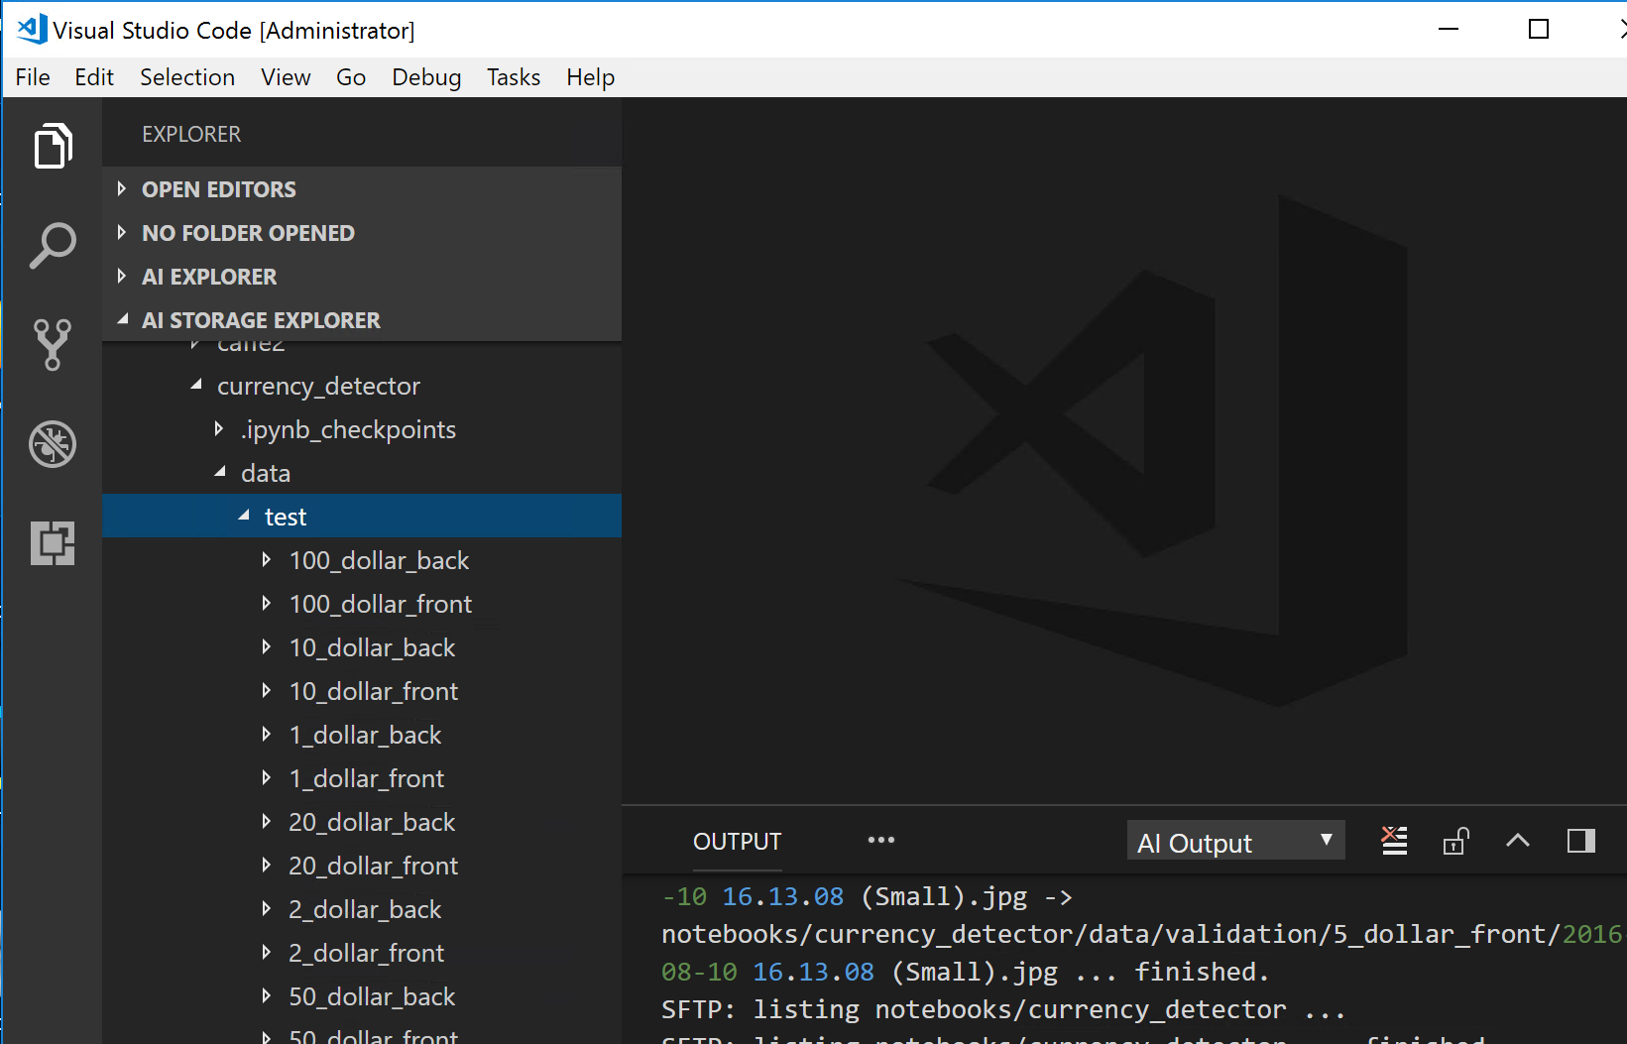

Once the files have finished uploading proceed to running the code in IDEs and Jupyter Notebooks.

# Run the code in Jupyter Hub Notebook

1. Open the Firefox browser on the Windows 2016 DSVM and enter the following URL:

https://<DNSname>:8000/hub/login or https://<PublicIP>:8000/hub/login

You can find the DNSname or Public IP in the Azure portal for your deployed Linux DLVM or DSVM

1. Login to Jupyter Hub with the Username and Password for the Linux DLVM or DSVM



Click on Start My Server



You can now see the folders we just uploaded using Visual Studio Code

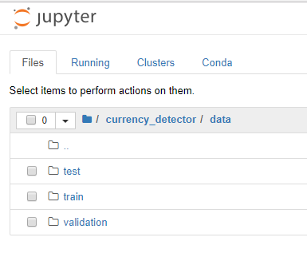

1. Open currency_detector.ipynb and choose Run All. Note that you can run one cell at a time by highlighting the cell and clicking Shift-Enter

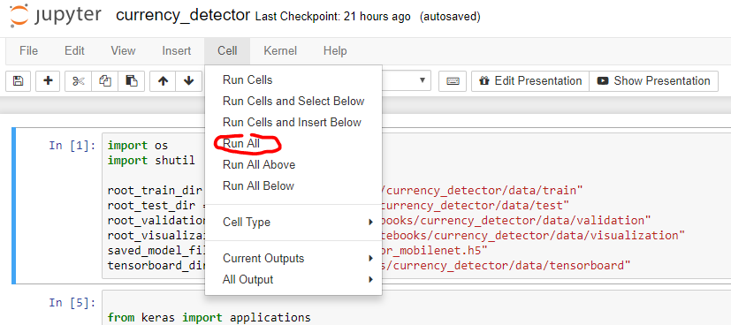

You should see the following when the second cell is running  
 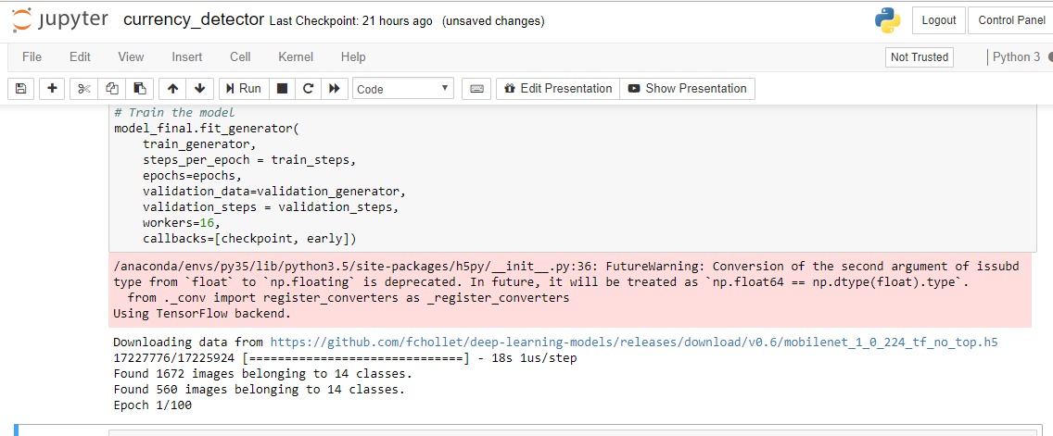

Note this is going to be slower if you can only use a CPU VM vs a GPU VM

Before running jobs on Visual Studio or VS Code. Required to Enable Remote Job Submission via Non-interactive Bash Session

<https://github.com/Microsoft/vs-tools-for-ai/blob/master/docs/tensorflow-vm.md>

Run this on the Linux DLVM or DSVM in the terminal

echo -e ". /etc/profile\n$(cat ~/.bashrc)" > ~/.bashrc

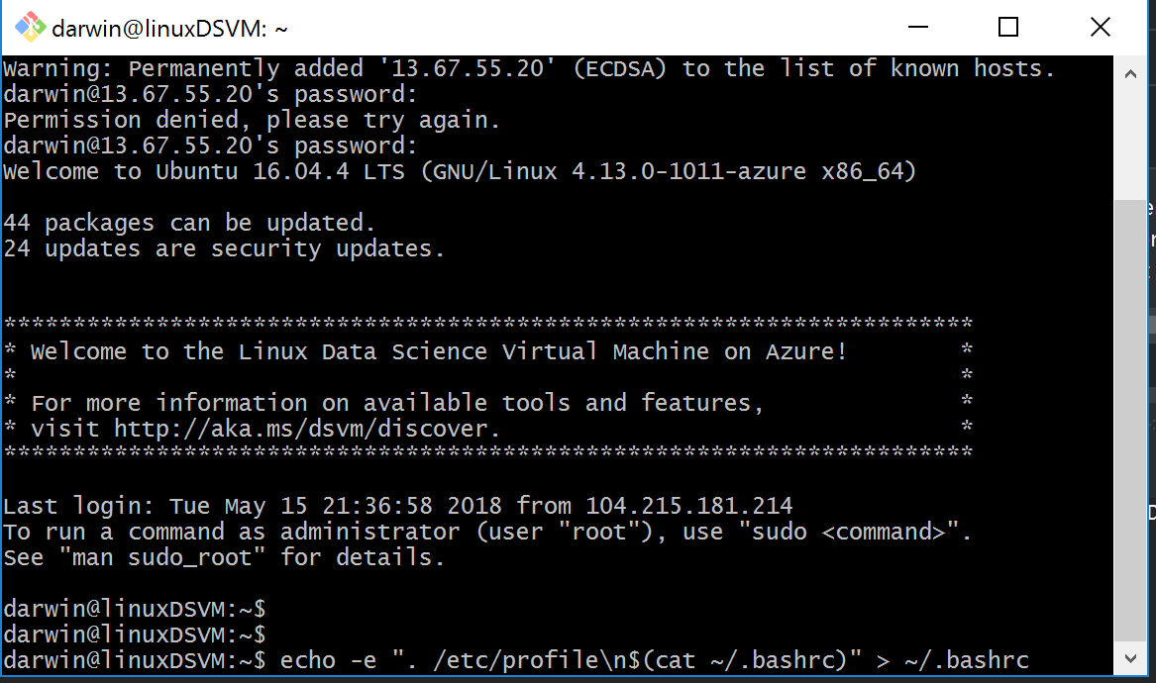

# Run the code in Visual Studio AI Tools

Note that you are not going to want to run this at the same time that the Juypter Notebook is running. This job will try to use the same resources.

1. Open the SeeingAICurrencyDetector Solution that you git cloned in step 56 above

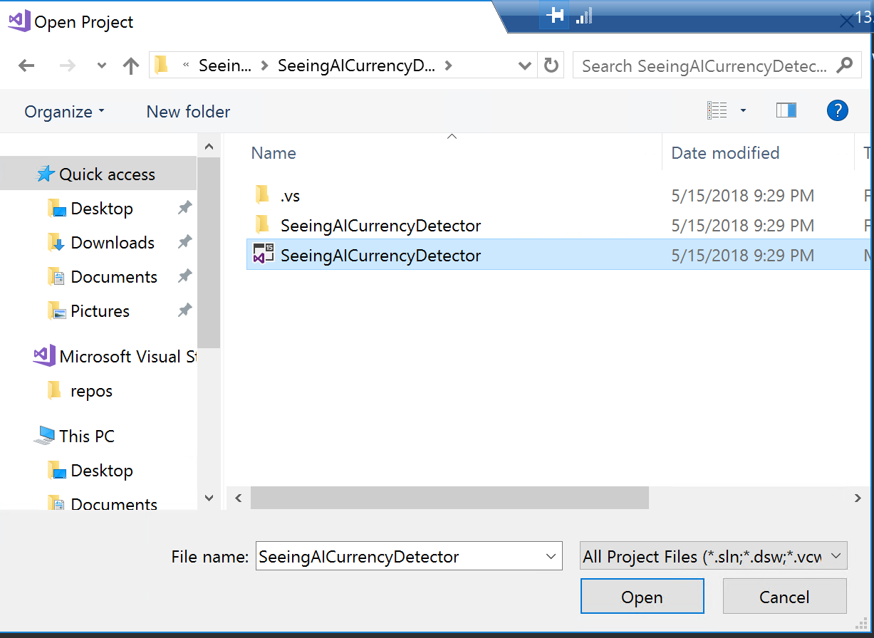

Open SeeingAICurrencyDetector.py

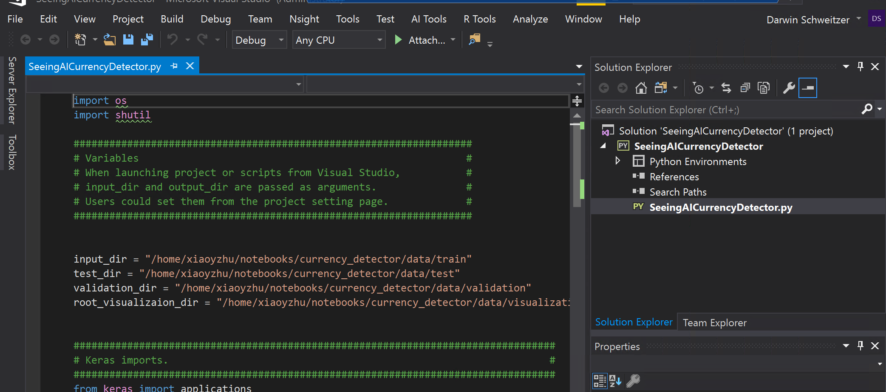

Replace the user in the paths to your user. In my case I change the user in the path to **darwin** vs the committer of the GitHub Repo **xiaoyzhu**

Consider using Find and Replace to find the 5 instances

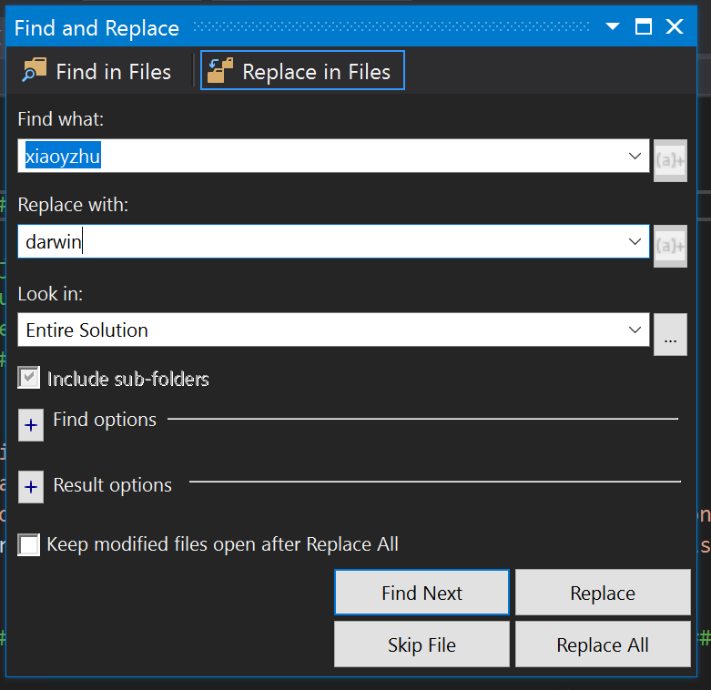

1. Edit the output to be 14 classes and save SeeingAICurrencyDetector.py  
     
   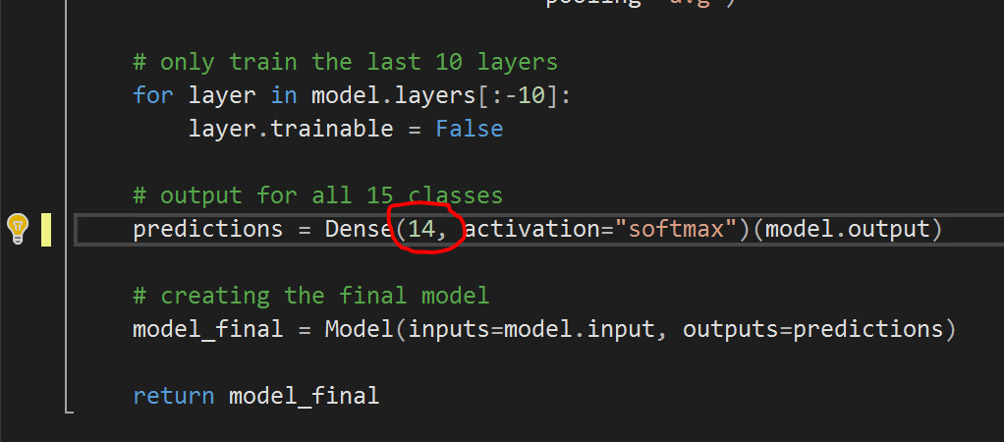
2. In Solution Explorer right click the SeeingAICurrencyDetector project and choose Submit Job  
     
   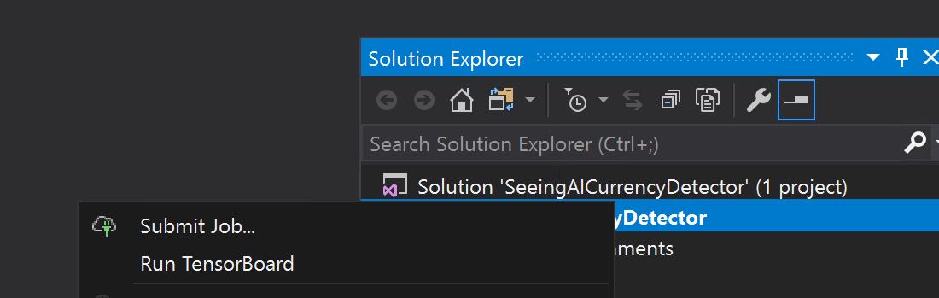
3. Select your Remote Machine, provide a Job name, and click Submit  
     
   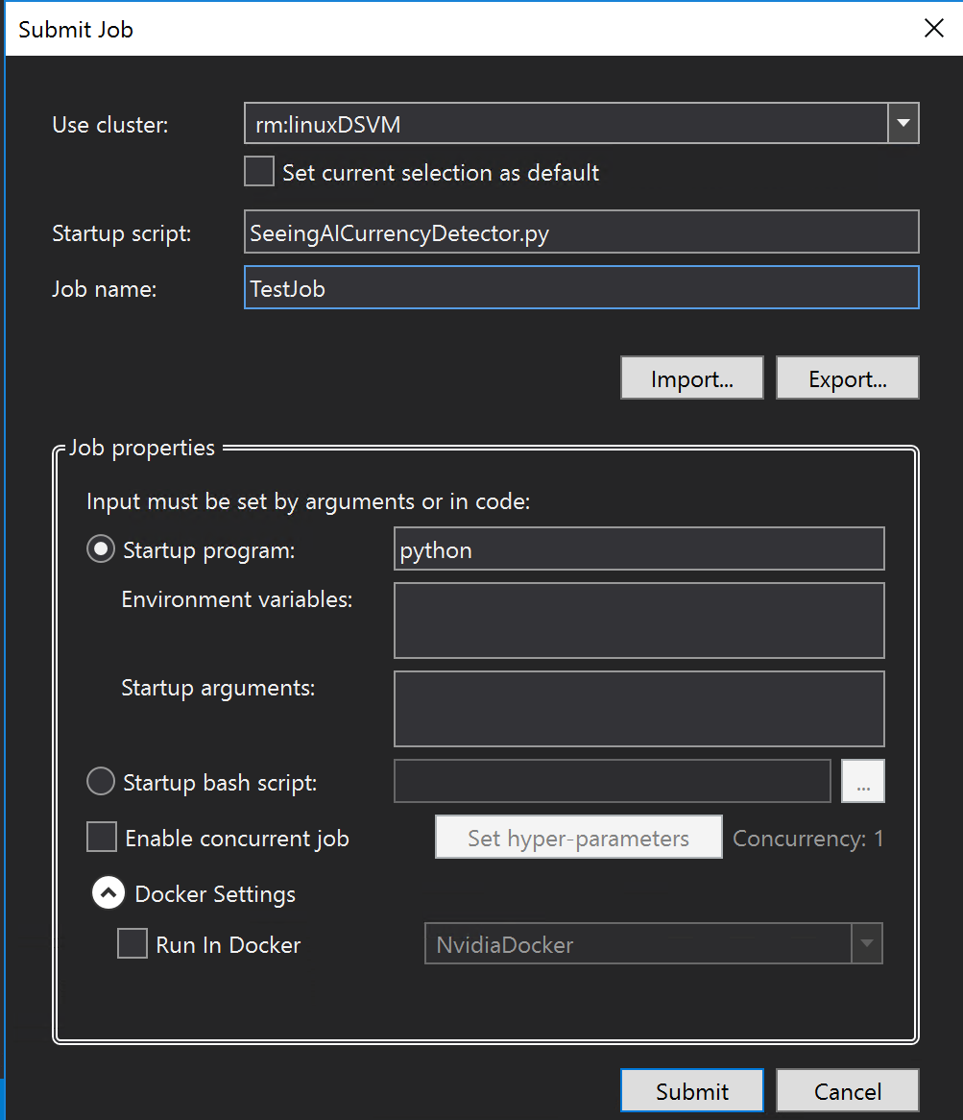
4. Browse the Jobs in AI Tools  
     
   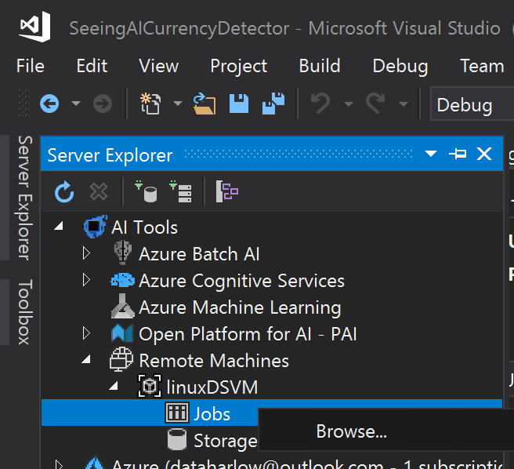
5. Here is the Job Browser. Check the **Stderr** and **Stdout** to check the progress off the Job  
     
   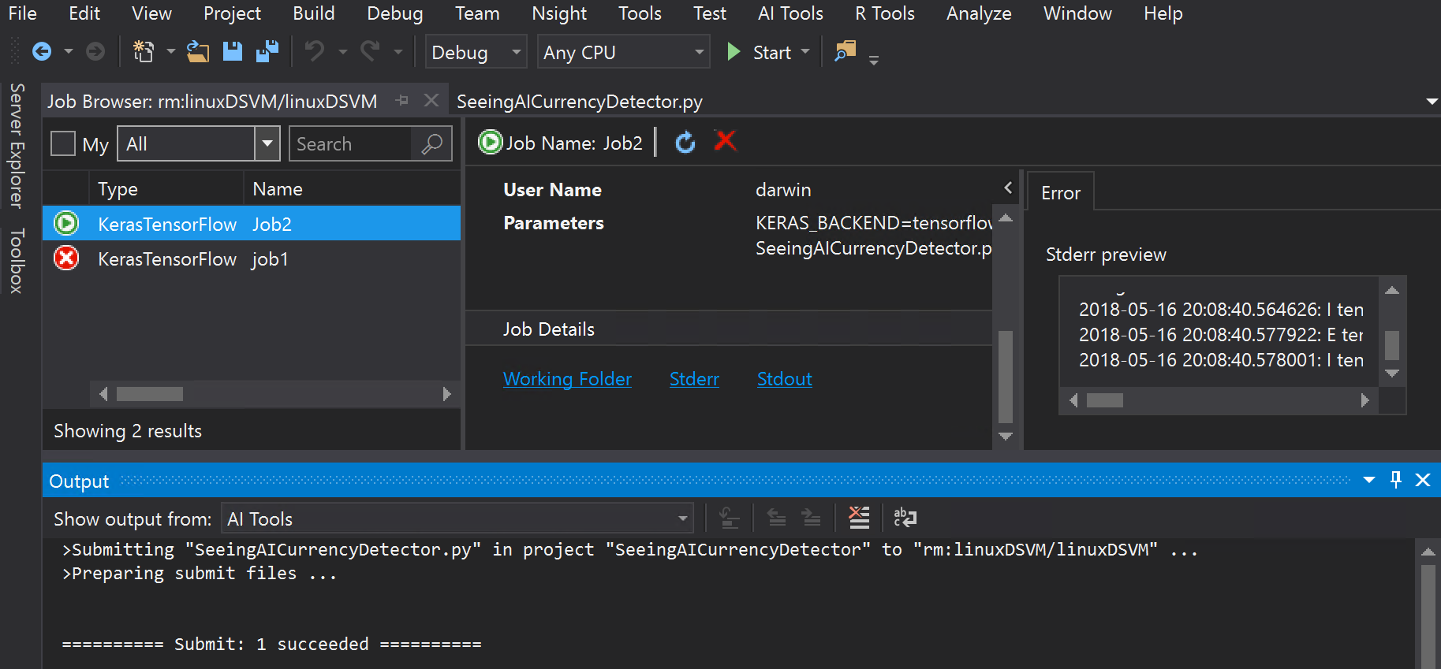

# Run the code in Visual Studio Code Tools for AI

Note that you are not going to want to run this at the same time as either the Juypter Notebook or Visual Studio Job. This job will try to use the same resources.

1. Copy the code in SeeingAICurrencyDetector.py and create a new file in VS Code and save it  
     
   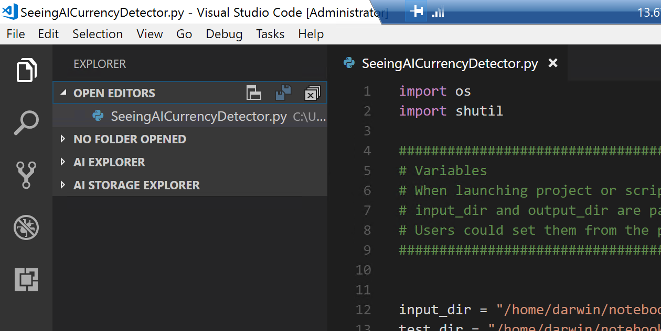

Note that you might need to update VS Code to use some features. Choose Restart to Update  
  
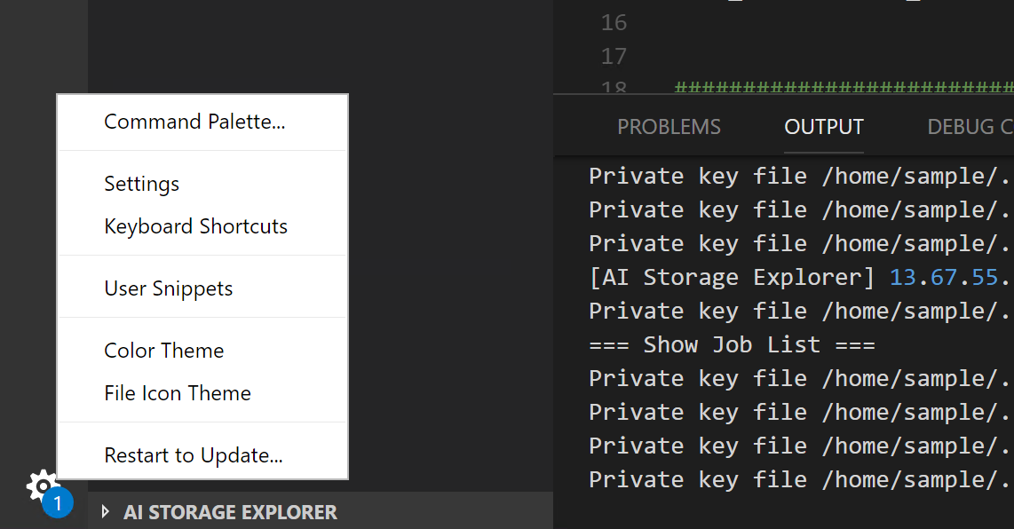

1. Right click on the Remote Linux server and choose Submit Job  
     
   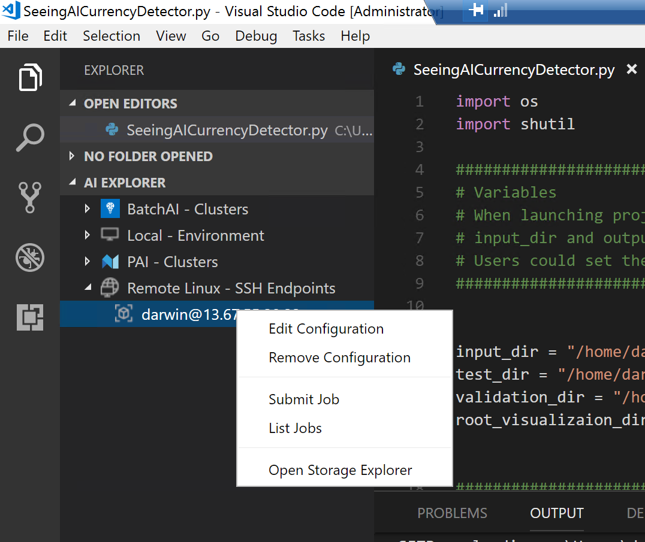

# Other Tools

1. The DSVM is also a fully configured Jupyter Notebooks Server on Windows (Different that Jupyter Hub which we used in this lab)

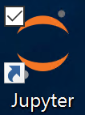

You can then open Jupyter from the desktop or browse to “https//localhost:8888/”.  
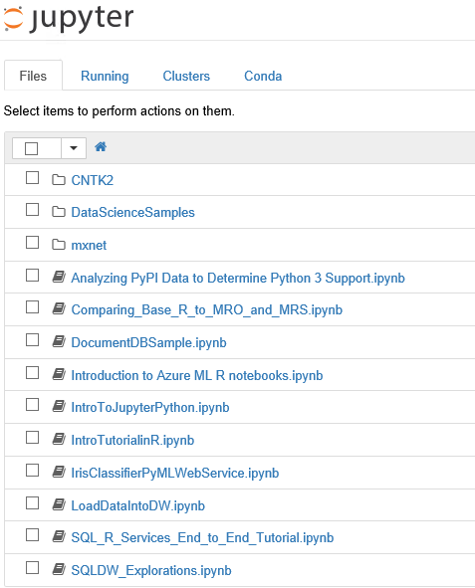  
The DSVM comes Loaded with multiple examples.

1. DSVM also has WEKA (Waikato Environment for Knowledge Analysis - popular data science tool) pre-installed. Please refer to <http://www.cs.waikato.ac.nz/ml/weka/documentation.html> for tutorial and resources.  
   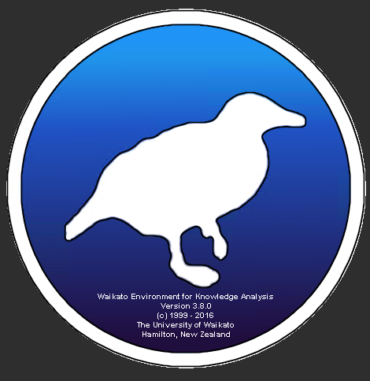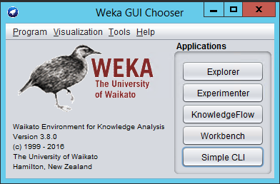
2. Rstudio is also installed on the DSVM

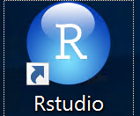

1. Visual Studio Code is installed

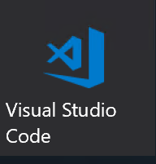

1. SQL Server is installed

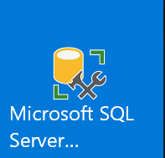

1. Power BI is installed

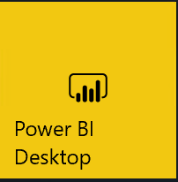

1. Git Bash is installed



1. Microsoft Azure Storage Explorer is installed

